# iG Chem ALL Summer Holiday Work for G2 June 2023

An electronic version of this document with hyperlinks is available through scanning the QR code

## **For all students, including those not studying chemistry at AS Level**

Lots of things influenced your choices for your AS Levels like: interest, enjoyment, university ambitions. But these choices also flow into your options at university.

The more thought and care you put into the choices you make from here on the more likely you will feel your **interests, responsibilities, passion**, and **joy** (aspects of your best, truest self) are fully represented in the work that you are doing.

**ALL students** should therefore try to think about possible careers, and the university degrees needed for them so that you can start your AS levels with a clearer understanding of where you are intending to go.

**The BEST** students will often change their minds about their dream career, but they will redirect themselves towards their new goals by finding out what they need to do to achieve them.

## Your dream career

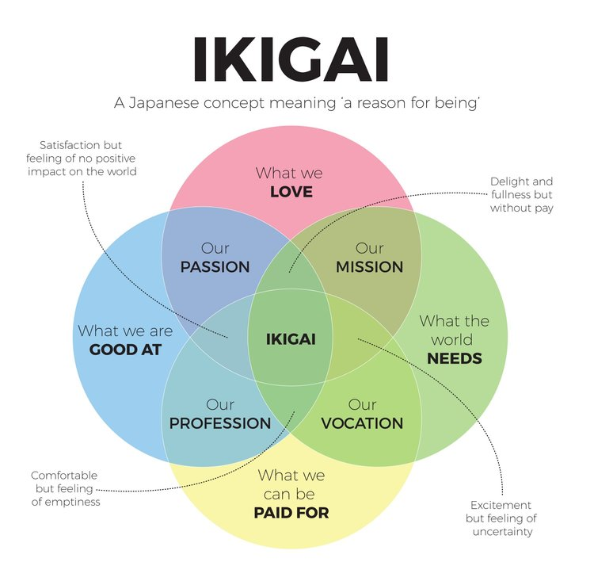



Everyone’s dream career will be slightly different, and adding a fifth, most important tiny circle at the centre might also include: “*What can support the health and happiness of ourselves and our family*”.

## Learning about your dream career

Like the Tao, the dream career you have is not your true dream career, there is always a way to make it better. But being relentlessly curious and steadily learning about careers, especially before you start working could be the most valuable and impactful work you ever do.

Use these websites to help you complete the table the follows:

* From the US Bureaux of Labour Statistics: <https://www.bls.gov/k12/>
* From UK National Careers Service: <https://nationalcareers.service.gov.uk/careers-advice>

|  |  |  |
| --- | --- | --- |
| **What do you like to do?** | **Possible jobs: What kinds of jobs do things like that?** | **What subjects help you get there** |
| 1. |  |  |
| 2. |  |  |
| 3. |  |  |
| 4. |  |  |
| 5. |  |  |
| 6. |  |  |

## Achieving your career goals – learning about the right degree for you

For a general overview of degrees go here:

<https://www.ucas.com/undergraduate/what-and-where-study/how-choose-right-undergraduate-course-you>

Most degrees from the top 30 universities in the UK are standard BA or BSc degrees in specific subjects, but it is helpful to find out about others if your career research suggests.

Complete this table using the UCAS website to help you (if you don’t have any career goals, ignore that column and just complete this for your degree goals):

|  |  |  |  |  |  |
| --- | --- | --- | --- | --- | --- |
| **Career** | **Degree subject and type** | **University** | **AS subject needed** | **AS grade needed** | **iGCSE grades needed (if given)** |
| 1. |  |  | 1. | 1. |  |
| 2. | 2. |
| 3. | 3. |
| 2. |  |  | 1. | 1. |  |
| 2. | 2. |
| 3. | 3. |
| 3. |  |  | 1. | 1. |  |
| 2. | 2. |
| 3. | 3. |
| 4. |  |  | 1. | 1. |  |
| 2. | 2. |
| 3. | 3. |
| 5. |  |  | 1. | 1. |  |
| 2. | 2. |
| 3. | 3. |
| 6. |  |  | 1. | 1. |  |
| 2. | 2. |
| 3. | 3. |

## Achieving your university goals – Turning your dreams into a plan with clear steps

The things that the best universities look for in their students, and will allow you the opportunities to work in your dream career, is evidence that you have certain key skills. These skills are essential to succeed when the work gets much harder at university, so if they chose the wrong student the results are very bad for everyone involved.

1. **Academic ability**

These they can in part find out from your iGCSE, AS and predicted A2 grades. But most of the students they reject will have the same straight A*s in the same subjects as the students they accept.

1. **Subject passion**

Students who enjoy and are interested in the subject they are studying are more likely to succeed than a student with the same grades but finds no enjoyment and is not interested in that subject. Both kinds of students might say they love it though, so universities can use the Personal Statement section of the university application (UCAS) form to find evidence to support a students passion for the subject.

If you go to the webpages below you can find out more how you can demonstrate subject passion (according to a college at Cambridge)

<https://www.trin.cam.ac.uk/access/help-and-advice/supra-curricular/>

Additional ideas are also available on this page of my website:

<https://www.smashingscience.org/expanding-your-mind>

1. **Study skills, organisational skills and community mindedness (including leadership)**

In addition to good grades and subject passion, the best universities also select for evidence of a student being an active participant and even leader in their current student life. Normally activates that demonstrate subject passion can also show this third and final set of attributes and skills.

Complete this table to help you plan better your super-curricular (also referred to: cocurricular and extracurricular) activities for the new academic year:

|  |  |  |  |
| --- | --- | --- | --- |
| Degree subject | Possible activity/ competition/ course to start or continue in | How long have you been doing it for? | Skill or attributes it might demonstrate |
|  |  |  |  |
|  |  |  |  |
|  |  |  |  |
|  |  |  |  |
|  |  |  |  |

Thinking **about deadlines** and when different courses need to be applied for by, start and finish, complete this table whenever you discover more information throughout the year:

|  |  |  |
| --- | --- | --- |
| Activity type | Apply by | Start by |
| School club or activity (already set up) | **Start of new semester** | **Start of new semester** |
| School club or activity (YOU set up, by yourself, or with friends) | Start thinking about this and have your ideas ready **over the summer** | If you intend to recruit other students, you need provide them with a good explanation of why your activity will help them/others by **start of next semester** |
| Course (e.g. from Coursera) | Ongoing – Find out (**Maybe soon**!) | Ongoing – Find out (**Maybe soon**!) |
| Internship (e.g. working in a lab in a university near where you live) | Ongoing – Find out (**Maybe soon**!) | Ongoing – Find out (**Maybe soon**!) |
| Competition (e.g. Olympiad) | Variable, ask your teacher!!! |  |
|  |  |  |
|  |  |  |
|  |  |  |
|  |  |  |