Learning to Learn

学习

Reading to Learn Effectively

Critical Reading Techniques
- Critical reading techniques
- Use an efficient approach
- Active reading
- How to take notes
- Critically processing what you read
- Coping with difficult content
Active reading simply means reading something with a determination to understand and evaluate it for its relevance to your needs.
Only reading and re-reading the material isn't an effective way to understand and learn. Actively and critically engaging with the content can save you time. Most OU study books and websites include in-text questions and self-assessed questions. Use these as built-in cues to make your study active.
Active Reading Advice –Core ideas
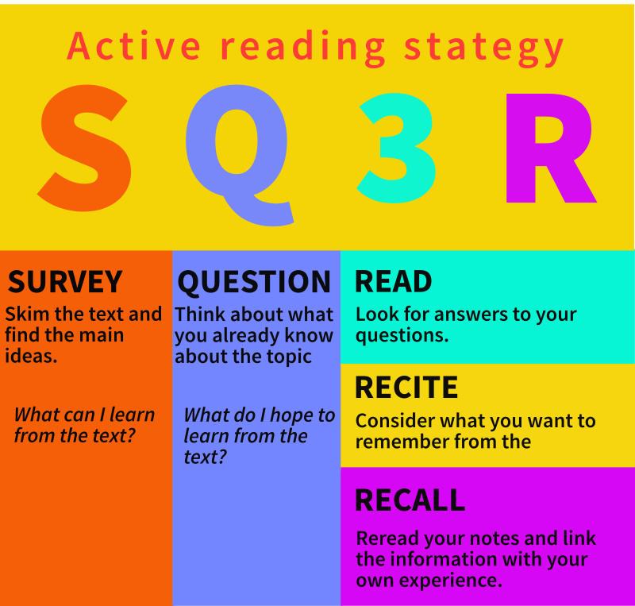
From: https://mcgraw.princeton.edu/sites/mcgraw/files/media/active-reading-strategies.pdf
学会学习

高效阅读学习

批判性阅读技巧

1. 批判性阅读技巧

2. 采用高效的阅读方法

3. 主动阅读

4. 如何记笔记

5. 批判性地处理阅读内容

6. 应对难懂的内容

主动阅读是指带着理解和评估其与自身需求相关性的决心去阅读。

仅仅反复阅读材料并不是理解和学习的有效方法。积极、批判性地参与到学习中可以节省时间。大多数开放大学的学习书籍和网站都包含课内练习题和自测题。利用这些内置的提示，让你的学习更加积极主动。

主动阅读建议——核心理念

Learning with your Textbook using Active Learning and Active Reading
The easiest to recommend textbook regardless of format is https://www.chemguideforcie.co.uk/
It is free and delivers enough content even for even a quite good A*, which is more than most A Level Chemistry textbooks for the CAIE syllabus offer. However, it is not that easy to print it out, so whatever printed textbook that CAIE recommends that is for the 2016 syllabus or later would be the way to go (newer would be better, but not by much).
Hopefully you have already started to notice certain patterns in all textbooks, like the way they are set out and structured. Normally one idea or concept (which are defined by the syllabus points) is covered in a section which gets its own heading, and these sections usually follow the order of the syllabus. In this way a larger syllabus topic is broken down into smaller parts
Usually there are also questions to test your understanding of the content, either after the section, or at the end of the chapter. These questions are not at all as carefully thought out or complex as exam questions but writing out the answers to them is still an effective way to get a longer lasting learning impact (more efficient) from the time invested. They are better than exam questions in the respect that they are answerable with just the information from that section you have just finished. Exam questions have been mapped to the syllabus topic in this and other workbooks, and to a Smashing!!! standard, but it is not always clear for Paper 2 and 3 which parts you should be able to answer when there are still important ideas within the topic that you have not yet started. You can however use Paper 1 questions, but this is less straightforward so not for all students.
Working through these questions in the textbook and making systematic notes is a part of a process known as Active Learning. Solving past exam questions is another way to learn by activity. Also effective is teaching another student who is struggling with a particular part of the course.
Active Reading requires you to really think about what you are reading and make notes, underline and reflect on the ideas in front of you. It is highly effective at making what you read understandable later on (part of the reading for meaning skill). The instructions in the next table will help you learn how to actively read, some or many will be things you already do, so concentrate on trying out the things you are not yet doing.
A common misconception, especially in lower levels of academic success, that the faster you read, the smart you are. Scanning for key information across pages is a vital skill that gets more useful at university. But by the far the strongest way to read the most complex types of literature is systematically with a deeply intellectually engaged process and by being profoundly open and vulnerable to changing your mind in the biggest and best ways. All of this takes care and especially time. It is also a skill, so you can get better at it. If you really like reading, or big ideas, or would like to spend more time with either or both check out: https://www.smashingscience.org/periodic-table-of-literature
Important points to note about the textbook
Sometimes there are differences between details in a textbook and in an exam mark scheme. Usually, the mark scheme would be the best version to learn (textbooks often have several mistakes in them, mark schemes almost never have any errors of any kind; so if there is a conflict, always assume the mark scheme is correct). The very best version would be one that includes details of both the mark scheme, which should be prioritised and then add whatever details the textbook also thinks is important.

利用教材进行主动学习和主动阅读

无论格式如何，最容易推荐的教材是 https://www.chemguideforcie.co.uk/ 。

它是免费的，内容丰富，即使是取得相当不错的 A* 成绩也绰绰有余，比大多数 CAIE 课程大纲的 A Level 化学教材都要好。但是，打印起来不太方便，所以最好选择 CAIE 推荐的 2016 年或之后版本的纸质教材（更新的版本更好，但差别不大）。

希望你已经开始注意到所有教材的一些共同模式，例如它们的编排和结构。通常，一个章节会涵盖一个概念或想法（由课程大纲定义），并有自己的标题，这些章节通常遵循课程大纲的顺序。这样，一个较大的教学大纲主题就被分解成更小的部分。

通常，每个章节之后或每章末尾都会有一些问题来检验你对内容的理解。这些问题远不如考试题那样精心设计或复杂，但写下答案仍然是一种有效的学习方法，可以让你更高效地利用时间，获得更持久的学习效果。它们比考试题更好的地方在于，你只需要掌握刚刚学完的章节内容就能回答这些问题。本书和其他练习册中的考试题都与教学大纲主题相对应，并且达到了“Smashing!!!”的标准，但对于第二卷和第三卷，当主题中还有一些重要的概念你尚未接触时，你并不总是清楚哪些部分需要回答。你可以使用第一卷的题目，但这不太直接，因此并不适合所有学生。

在课本上做这些练习题并系统地做笔记，是被称为“主动学习”的过程的一部分。解答过去的考试题是另一种通过活动进行学习的方法。辅导其他在课程某个部分遇到困难的学生也同样有效。

主动阅读要求你认真思考阅读内容，做笔记、划线，并反思眼前的观点。它能极大地帮助你日后理解阅读内容（这是理解阅读技巧的一部分）。下表中的说明将帮助你学习如何进行主动阅读，其中一些或很多方法你可能已经掌握，所以请专注于尝试那些你尚未掌握的方法。

一个常见的误解，尤其是在学业成绩较低的学生中，是认为阅读速度越快就越聪明。快速浏览页面寻找关键信息是一项至关重要的技能，在大学里会更加实用。但迄今为止，阅读最复杂文学作品的最佳方法是系统地、深入地投入思考，并保持开放的心态，随时准备以最佳方式改变你的想法。所有这些都需要细致的思考，尤其是时间。这也是一项技能，所以你可以不断提高。如果您热爱阅读、喜欢钻研深奥的思想，或者想花更多时间钻研这两者，请访问：https://www.smashingscience.org/periodic-table-of-literature

关于教材的要点

有时，教材和考试评分标准中的细节会有所不同。通常情况下，评分标准是最佳学习版本（教材中经常出现一些错误，而评分标准几乎不会出现任何错误；因此，如果两者存在冲突，请始终以评分标准为准）。最佳版本应该包含评分标准中的所有细节（应优先考虑评分标准），然后再添加教材中认为重要的其他细节。

Activity  活动 | What you should do  你应该怎么做 | Why it helps  它为何有用 | When you should do it  何时应该这样做
- Underlining  下划线 | Underline, bold, CAPPITAL LETTERS, highlight circle , put a *star or symbol 😉 next to the biggest new ideas. But remember, if you highlight everything, you’ve actually highlighted nothing ☹.  用下划线、粗体、大写字母、高亮圈标记，在最重要的新想法旁边加上星号或符号😉。但记住，如果你把所有内容都标记出来，实际上就等于什么都没标记☹。 | This is where Active Reading and Active Learning begins, but it should not be where it ends.  Students who are more capable sometimes do less well because they chose to annotate the textbook instead of their notes. Whatever you do in the textbook is building on work your brain knows is not its own, so it is less interested in it. That also makes it easier and therefore more appealing, but it is much less effective use of time.  主动阅读和主动学习由此开始，但绝不应止步于此。  有些能力较强的学生，由于选择在课本上做批注而非记笔记，反而表现不佳。你在课本上所做的任何标注，都是建立在你大脑认为并非自身独立完成的工作之上，因此大脑对此兴趣不大。这固然使标注变得更容易，也更具吸引力，但却大大降低了时间利用效率。 | As you are reading.  就像你现在正在阅读的那样。
- Answers to questions in the textbook  课本中问题的答案 | Write the title of the section, date, textbook page number, then answer the question in a way that allows you to use these answers as notes months or even years from now. Therefore, use complete sentences, include as much detail as is needed in your answer for it to make sense. Include all of the working for the calculation. Answer all of these questions either with your main class notes, or a specific notebook.  请写下章节标题、日期、课本页码，然后以便于日后查阅的方式回答问题。因此，请使用完整的句子，并尽可能详细地阐述答案，使其通顺易懂。请列出所有计算步骤。所有问题的答案都可以使用课堂笔记或专门的笔记本。 | Remember you are aiming to learn the idea, not just reproduce mark scheme, so your work should reflect that intention. For each question’s answer you are essentially summarising the question and the idea in your answer, which is a creative, analytical and reflective process; all of these higher order thinking skills in one activity is a very powerful way to systematically actively learn using the textbook.  记住，你的目标是理解概念，而不仅仅是照搬评分标准，所以你的答案应该体现这一意图。对于每个问题的答案，你本质上是在总结问题和概念，这是一个创造性、分析性和反思性的过程；将所有这些高阶思维技能融合在一个活动中，是一种利用教材进行系统性主动学习的有效方法。 | As you are reading.  就像你现在正在阅读的那样。
- Answers to worked examples  例题解答 | Answer the worked examples whenever you get to them. Cover up the explanation with a piece of paper so you can only see the question. Include your working, with clearly labelled numbers and equations. After you have written out your answer then check to see if you understood the calculation.  看到例题时，请立即解答。用纸片遮住答案解析，只留下题目。请写出你的解题步骤，数字和公式都要清晰标注。写完答案后，检查一下你是否理解了计算过程。 | You are building not only the skill to get the right answer, but also the skill to deliver an answer in an exam that gets all of the marks, including the hardest marks for details that most students who know the answer lack the exam technique to include.  你不仅培养了获得正确答案的技能，还培养了在考试中给出正确答案并获得所有分数的技能，包括那些大多数知道答案的学生缺乏考试技巧而无法包含的细节分数。 | As you are reading.  就像你现在正在阅读的那样。
- Create an introduction mind map of key points and essential aspects  创建一份包含要点和必要方面的介绍性思维导图 | Create a mind map of the topic as you learn it.  Include essential diagrams, equations, keywords and connections as you come across them.  Try to be creative, visual and colourful.  Make sure whatever you write is in your own words.  You can tape securely sticky notes to add to areas that need more space.  This can be the first page in your notes. It will grow as you are encounter new ideas.  学习过程中，绘制主题思维导图。  遇到重要的图表、公式、关键词和关联时，及时添加进去。  尽量发挥创意，运用视觉元素和色彩。  确保所有内容都用你自己的语言表达。  你可以用便利贴牢固地粘贴在需要更多空间的地方。  这可以作为笔记的第一页。随着你遇到新的想法，它会不断扩展。 | You will be using, exploring and growing your creativity, analysis skills, your visual understanding of the topic as well as your ability to summarise large amounts of information into a small space.  You are unlikely to do this well for Topic 1. But by Topic 37 you will be an expert at this highly specialised and efficient way to study using a written source.  你将运用、探索并提升你的创造力、分析能力、对主题的视觉理解能力，以及将大量信息浓缩成简洁信息的能力。  你不太可能在第一单元就做到这一点。但到了第37单元，你将成为这种高效且高度专业化的书面资料学习方法的专家。 | As you are reading.  就像你现在正在阅读的那样。
- Create summary sentences of textbook sections  撰写教科书章节的概要句子 | You can create condensed sentences with the essential points as you go for each section. You could write all of them for a chapter together on the same page, clearly indicating the pages each sentence relates to (and the date).  你可以一边写一边提炼每个章节的要点，形成简洁的句子。你也可以把一章的所有要点都写在同一页上，并清楚地标明每个句子对应的页码（以及日期）。 | Another way of thinking about it is: what’s the least useful or least important 90% content in a section?  换个角度思考：一个章节中，最无用或最不重要的 90% 的内容是什么？ | As you are reading.  就像你现在正在阅读的那样。
- Read ahead and write out questions to ask in class  提前阅读并写下要在课堂上提出的问题。 | Read ahead in the topic you are studying in class and write out questions about the material you have encountered that it’s not well or fully explained by the textbook. Ask these questions at the end of class, or after class if the lesson has not answered them.  课前预习一下课堂上学习的主题，并写下你遇到的、课本解释不够透彻或不够全面的问题。如果课堂上没有解答这些问题，可以在课后或课后提出。 | Asking good, insightful questions is an important skill to improve.  Don’t ask these questions before the content has been taught – the best value of the activity lies in your carefully listening throughout the whole lesson to make sure the question was not answered; often it will have been.  You are aiming to learn better in the scheduled time. This is a highly effective way give yourself extra incentive to pay extra attention.  提出好的、有见地的问题是一项需要提升的重要技能。  不要在讲解内容之前提问——这项活动的最大价值在于你全程认真聆听，确保问题没有被解答；通常情况下，问题已经被解答过了。  你的目标是在预定时间内更好地学习。这是一个非常有效的方法，可以激励你更加专注。 | As you are reading.  就像你现在正在阅读的那样。
- Read and practice past exam questions  阅读并练习往年考题 | Carefully select parts of exam questions you can answer from what you have already learnt about the topic.  MCQ questions usually are the most compartmentalised and focus on individual syllabus points, so they tend to be the best questions to try when you are still studying the topic.  You might be able to answer some questions on the topic you are currently learning in written exam papers, or at least can read through them and look for the parts that you can do.  仔细挑选你能用已学知识回答的考题部分。  选择题通常比较具体，侧重于各个知识点，因此在你还在学习某个主题时，这类题型往往是最佳选择。  你或许能在笔试卷中找到一些与你正在学习的主题相关的题目，或者至少可以通读试卷，找出你能解答的部分。 | Learning a topic with and knowledge of they kinds of questions you will be asked can help you understand the relevance of what you are learning and centre it on practical skills and understanding that will soon be essentially to gaining a good grade. It can also help you to create questions in your mind about things you have yet to see, so that you are curious to find out the answer.  学习某个主题并了解你可能会被问到的问题类型，可以帮助你理解所学内容的意义，并将学习重点放在实用技能和理解上，这对取得好成绩至关重要。它还可以帮助你对尚未接触过的内容产生疑问，从而激发你寻找答案的好奇心。 | As you are reading.  就像你现在正在阅读的那样。
- Add to your Cornell Notetaking Notes from class  把课堂笔记添加到你的康奈尔笔记中 | Add any details you are missing in your class notes on a section in a way that allows you to see what came from a textbook (e.g. by highlighting that text, or different colour only used for content from the textbook).  在课堂笔记中，以能够让你看到哪些内容来自教科书的方式，添加你遗漏的任何细节（例如，通过突出显示该文本，或者仅使用不同的颜色来表示来自教科书的内容）。 | You will have to read and understand all of your notes and the textbook content before you decide to add and write out these additional details. You are far more likely to check if this content really isn’t in your notes, making you compare and contrast the content of both much more thoughtfully, again using and growing your thinking skills for this topic.  在决定添加和记录这些额外细节之前，你必须阅读并理解所有的笔记和教科书内容。如果这些内容确实不在笔记中，你很可能会去检查，这会让你更深入地比较和对比两者的内容，从而再次运用和提升你在这个主题上的思考能力。 | After you have studied the textbook’s section in class.  在课堂上学习完课本的相关章节之后。
- Add to your Cornell Notetaking Cue column  添加到你的康奈尔笔记提示栏 | Cover up you Cornell cue column for a section you have studied both in class and from the textbook. Does this cue column have everything it should, or are there details, keywords or questions you now know that are missing?  Add to your cue column in your Cornell Notes any additional details, keywords or questions that you have.  遮盖住你康奈尔笔记中已在课堂和教材中学习过的章节的提示栏。这个提示栏是否包含了所有应该包含的内容？或者是否遗漏了你现在知道但尚未包含的细节、关键词或问题？  将你补充的任何细节、关键词或问题添加到康奈尔笔记的提示栏中。 | If you covered up the notes section of the page, answering these questions should allow you revise the whole page simply by answering the questions you have written out and thinking about a few core ideas (much more efficient revision, for instance before you start practicing past exam questions).  如果你遮盖了页面上的笔记部分，那么回答这些问题应该可以让你通过回答你写下的问题并思考一些核心概念来复习整页内容（例如，在你开始练习过去的考试题之前，这是一种更高效的复习方式）。 | After you have studied the textbook’s section in class.  在课堂上学习完课本的相关章节之后。
- Add to your Cornell Notetaking Summary sections  在康奈尔笔记总结部分添加内容 | Read carefully what you have already written in the cue column and the summary section of your notes. What additional sentence could you add to make it better? Write it in a specific colour so you can easily and quickly see this most sophisticated and important (to you) sentence that can lead you back to your thinking when it was written after finishing your lessons and your notes of the whole topic.  仔细阅读你笔记中提示栏和总结部分的内容。你还可以添加哪句话来完善它？用特定的颜色写下这句话，这样你就能快速轻松地找到它，因为它能帮助你回顾当初完成课程和笔记后写下这段话时的思路。 | Another way of thinking about it is: what’s the least useful or least important 80-90% content here?  换个角度思考：这里最无用或最不重要的 80-90% 的内容是什么？ | After you have studied the textbook’s section in class.  在课堂上学习完课本的相关章节之后。
- Create a summary mind map  创建概要思维导图 | Using the introductory mind map create a summary map that summarises everything in a logical and well presented and well set out ways.  利用介绍性的思维导图，创建一个总结图，以逻辑清晰、条理分明的方式概括所有内容。 | A great quick revision strategy is to write out a mind map for the entire topic on a blank piece of paper, from memory. Then to check it with a mind map like this one, and look for the things you missed out, you now know what to concentrate on.  一个很棒的快速复习策略是，凭记忆在一张白纸上画出整个主题的思维导图。然后，用像这样的思维导图进行核对，找出遗漏的内容，这样你就知道该重点关注哪些方面了。 | After you have finished the textbook chapter in class, but before the topic test.  在课堂上学完课本章节之后，但在进行专题测试之前。
- Add to your Cornell Notes any final essential textbook details you missed  把你遗漏的任何重要的教科书细节添加到康奈尔笔记中。 | Add whatever details into your notes that your past exam question practice highlights that was in the textbook but that you missed, both when you were studying it in class and when you were reading it. Try to think about how you could in the next Topic spot and learn these kinds of subtle and easy to miss ideas that deliver the harder marks earlier. This is the highest level of reflection, using data and systems to deliver the easiest to miss improvements that only the best students can make.  把以往考题练习中发现的、课本里有但你课堂上和课后阅读时遗漏的细节都记入笔记。试着思考一下，在下一个学习主题中，如何才能更早地掌握这些容易被忽略的、能带来更高分数的关键知识点。这是最高层次的反思，它运用数据和系统来发现那些只有最优秀的学生才能做到的、最容易被忽视的改进之处。 | The tricky marks and the slippery explanations (especially that 2nd or 3rd mark) often follow patterns that can make it much easier to spot once you have thought not about the answer, or even the question, but those underlying patterns examiners use to make content more complex (so that it is a question for a 18 year old instead of a question for a 13 year old). Sometimes those patterns are addressed in a textbook, when you miss them in one textbook chapter, you should try to be more deliberate and thoughtful to see them in the next topic.  那些刁钻的分数和模棱两可的解释（尤其是第二或第三分）往往遵循某种模式。如果你不去思考答案，甚至不去思考题目本身，而是去留意考官用来使内容更复杂（让题目更适合18岁的人而不是13岁的人）的潜在模式，就能更容易地发现这些陷阱。有时，这些模式会在教科书中有所提及。如果你在某一章节中错过了它们，就应该更加仔细地思考，以便在下一章节中发现它们。 | As you are practicing the past exam questions.  当你练习往年考题时。
- Write out your own Top Tips  写下你自己的实用技巧 | Write out any new tough marks or details that you have overlooked and try to think of a rule or piece of advice, to yourself and others, about how to effectively build an exam habit so you don’t drop a mark from that kind of problem or puzzle again.  写下你忽略的任何新的难点或细节，并试着为自己和他人制定一条规则或建议，以有效地养成考试习惯，这样你就不会再因为这类问题或难题而丢分。 | Ultimately, you are not aiming to deliver into your life a library of facts, but an active and growing library of learning systems.  You are building a way of incrementally grow your problem solving ability to achieve important life goals through pattern recognition, diligent perseverance and creative reflection.  最终，你的目标并非为生活构建一个事实库，而是建立一个活跃且不断增长的学习系统库。  你正在构建一种方法，通过模式识别、勤奋坚持和创造性反思，逐步提升解决问题的能力，从而实现重要的人生目标。 | Any time after you’ve finished the topic, but before the main exam.  完成该主题学习后，但在正式考试之前的任何时间。

The Cornel Note-Taking System
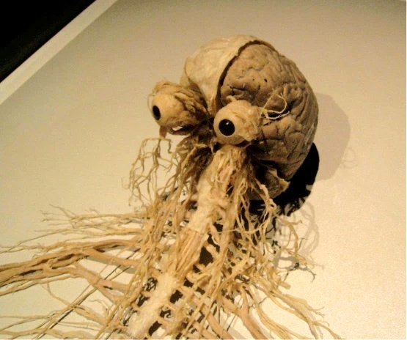
Background science – your brain is an organ
As important as remembering important things is forgetting everything else. Your brain does both. Learning well is like programming a computer, using specific ways to best interact with this mysterious organ so that you can remember information and connect ideas in new ways, so you can solve new problems like an exam question you have never tried before.
Most details of most seconds, minutes and hours of anyone’s life are not needed and are deleted (forgotten). But if you have ever fallen off a bike or had an accident your brain stops deleting everything and instead stores as much of the information as it is able. Time slows down and your memory feels almost photographic. Some things are therefore more memorable than others. The trick with learning is to present information and skills to your brain in just the right way so that it stores these memories longer term.
Figure 1 It’s what’s on the inside that counts! This organ is where almost all of your mind comes from. Other factors like adrenalin, a powerful fast-acting hormone from glands in the body, outside the brain, also shape your thinking.
It is designed to only remember the things that it is programmed to think are important. It’s programming comes from culture, but some is also hard-wired into the system itself, like our shared interest in learning a language when we are babies, or our ability to process visual images better or our ability to control our body temperature. This hard wiring is created by our genes, which we inherit from our parents. Our genes were created and adapted to survive and reproduce tens of thousands of years ago living lives that are totally alien to even the most extreme high school environment.
Current understanding of the human brain is extremely basic, no-one knows what the smallest part, or atom, of an idea might be in terms of brain cells. But we do know that brain cells make connections, and we think that those connections are where the mind, and memory, is created. We also know that the brain is more likely to make connections, and therefore memories, from events we are emotionally attached to, like an accident or a totally awesome movie. If we feel more emotions about something our brain is adding meaning to the memory, and it is much more likely to be stored longer term.
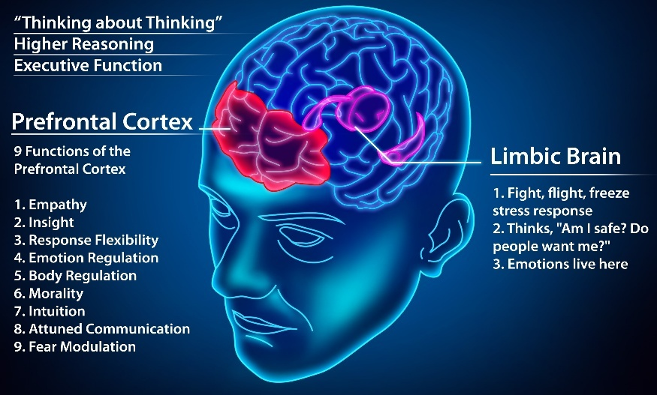
If you keep returning to the same idea over time, but you make your brain think about it differently, for instance by taking notes using your own words, or making a summary, or writing out key questions raised by that idea, you are making your brain to make new connections to make this new kind of thinking happen. Not only will the brain be better able to use new ideas in a new situation, like in an exam, but these connections also make the memory more stable. If the brain really thinks something is important, like something that hurt you or where you live, it will store these essential bits of information into what can be called long-term memory.
Figure 2 The business end of the organ. The human brain is special not for its size, whale brains are bigger, but for its uniquely complex prefrontal cortex which does much of the best thinking, it also delivers the higher order thinking skills you will need to plan and deliver the revision needed to crush your exams.
The limbic brain adds emotional weight to your ideas, it powerfully moderates your thinking and adds a difficult to describe property that can be simplified to as “meaning” to thoughts and memories.
The goal of learning is not only to make as many interesting and important connections within the brain as possible, but also to put as much key information into the long-term storage area as possible. The goal of education, especially in the better universities is not fill a student’s brain with specific facts and ideas, or to test how intelligent someone was born, but to train a student’s brain with valuable skills and techniques to learn faster, better and longer.
Learning how to learn better is the most valuable and important thing you will take away from any period of education. Luckily, you are not the first person to have ever been taught. There are thousands of years of history and tens of thousands of years of culture that you can use to your advantage. Some systems of learning work better than others. The world’s best universities have done a great deal of research into these different systems and skills involved in learning e.g.:
https://english.gse.pku.edu.cn/newsandevents/news/index.htm (Peeking University); https://www.ucl.ac.uk/ioe/research ; https://www.gse.harvard.edu/ideas ; https://web.edu.hku.hk/knowledge-exchange (Hong Kong University) ; https://nus.edu.sg/cfg/students (National Uni of Singapore) ; https://ed.stanford.edu/faculty/overview ; https://www.ioe.tsinghua.edu.cn/en/Education/Summer_School.htm ; https://www.educ.cam.ac.uk/research/impact/ (Cambridge); Institute Of Education What Works Clearinghouse (USA); https://as.cornell.edu/education/education-innovation ;
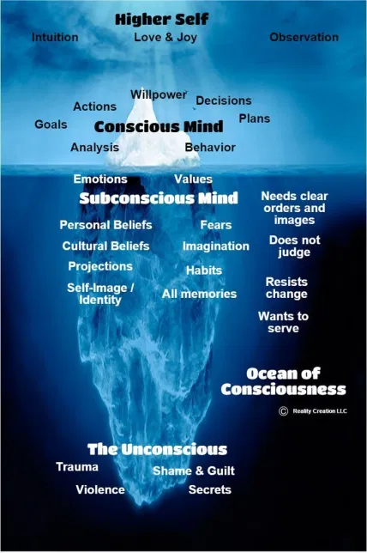
The Cornell Notetaking System
In the 1940s a professor of law at Cornell University called Walter Paulk realised his students, who were supposed to be some of the best of their generation, weren’t that good and he wondered what they could do to learn better. He invented the Cornell Notetaking system, which is widely considered to be the best way to learn difficult things faster for almost any subject at both the High School and University level.
Notetaking is not about storing information that you need to relearn before the exams, rather it is like creating structured save points on your journey to understanding a syllabus point. The notes you have made have created connections in your brain that are reactivated when you see your notes again. Your notes are a visual key or code that transports your mind not to one part of the idea, but rather to all of the connections you had to make when the notes were created. You are retrieving the whole box of memories, skills and connections, instead of a single piece of the bigger topic.
These notes are therefore a way to neatly store away not facts, but how all of those facts interconnect (understanding) in an orderly way through an organised process that uses what we know about the brain as a biological, evolved organ.
Figure 3: The mind is a small part of the brain. But the conscious mind is a smaller part of the whole mind. Most of the mind involves aspects of the self that are hard to understand and even harder to change, but with enough work it is possible for anyone to nurture and grow the habits of an outstanding student. These larger changes take time, hard work and especially a commitment to try new things.
A key feature of this system is making your brain think about priority, order and relationships that make a lessons worth of ideas at different times. Even more effective thinking about the same idea in a creative way after several nights of good sleep. The Cornell Notetaking system includes all of these most effective learning strategies.

康奈尔笔记系统

背景科学——你的大脑是一个器官

记住重要的事情固然重要，但忘记其他一切也同样重要。你的大脑两者兼备。高效学习就像给电脑编程，需要用特定的方式与这个神秘的器官进行最佳互动，从而记住信息，并以新的方式将各种想法联系起来，最终解决从未遇到过的难题，例如考题。

每个人生命中的大部分时间（秒、分钟、小时）的细节都是不必要的，会被删除（遗忘）。但如果你曾经摔倒过或发生过意外，你的大脑就不会再删除所有信息，而是尽可能多地存储起来。时间仿佛慢了下来，你的记忆力几乎像照片一样清晰。因此，有些事情比其他事情更容易记住。学习的诀窍在于以恰当的方式向大脑呈现信息和技能，使其能够长期存储这些记忆。

大脑的设计使其只会记住那些被程序设定为重要的信息。大脑的运作机制源于文化，但有些也根植于系统本身，例如我们婴儿时期对学习语言的共同兴趣，我们处理视觉图像的能力，以及我们控制体温的能力。这种根植于基因的形成，而基因则遗传自父母。我们的基因在数万年前被创造和适应，以求在与如今极端的高中环境截然不同的环境中生存和繁衍。

目前我们对人脑的理解还非常基础，没有人知道构成一个想法的最小单元（或原子）在脑细胞层面上是什么。但我们知道脑细胞会建立连接，我们认为这些连接正是思维和记忆的形成之处。我们也知道，大脑更容易将我们情感上依恋的事件（例如事故或一部精彩绝伦的电影）与大脑连接起来，从而形成记忆。如果我们对某件事有更强烈的情感，我们的大脑就会赋予记忆更深层的意义，而这些意义也更容易被长期储存。

如果你反复思考同一个想法，但每次都用不同的方式思考，例如用自己的话做笔记、总结或写下这个想法引发的关键问题，你就能促使大脑建立新的连接，从而产生这种新的思维方式。这样一来，大脑不仅能更好地在新的情境（例如考试）中运用新的想法，而且这些连接还能使记忆更加稳定。如果大脑认为某件事很重要，例如让你受伤的事情或你居住的地方，它就会将这些重要的信息存储到所谓的长期记忆中。

学习的目标不仅在于尽可能多地在大脑中建立有趣且重要的连接，还在于尽可能多地将关键信息存入长期记忆区域。教育的目标，尤其是在优秀的大学里，不是将具体的知识和想法塞进学生的脑子里，也不是测试一个人的智力水平，而是训练学生掌握宝贵的技能和方法，从而更快、更好、更持久地学习。

学习如何更好地学习是你在任何教育阶段所能获得的最有价值、最重要的收获。幸运的是，你并非第一个接受教育的人。你可以利用数千年的历史和数万年的文化积累来提升自己。有些学习体系比其他体系更有效。世界顶尖大学对这些不同的学习体系和相关技能进行了大量研究，例如：

https://english.gse.pku.edu.cn/newsandevents/news/index.htm（北京大学）；https://www.ucl.ac.uk/ioe/research；https://www.gse.harvard.edu/ideas；https://web.edu.hku.hk/knowledge-exchange（香港大学）；https://nus.edu.sg/cfg/students（新加坡国立大学）；https://ed.stanford.edu/faculty/overview； https://www.ioe.tsinghua.edu.cn/en/Education/Summer_School.htm；https://www.educ.cam.ac.uk/research/impact/（剑桥大学）；教育学院“有效教学资源中心”（美国）；https://as.cornell.edu/education/education-innovation；

康奈尔笔记法

20世纪40年代，康奈尔大学法学教授沃尔特·保克意识到，他那些本应是同代最优秀学生的学生，学习成绩却并不理想。他开始思考如何才能帮助他们更好地学习。于是，他发明了康奈尔笔记法。这种方法被广泛认为是高中和大学阶段几乎所有学科快速学习难点知识的最佳方法。
记笔记并非为了在考试前重新学习信息，而是为了在理解课程要点的过程中建立结构化的记忆节点。你所做的笔记会在大脑中建立连接，当你再次看到这些笔记时，这些连接就会被重新激活。笔记就像一把视觉钥匙或密码，它引导你的思维回到你创建笔记时建立的所有连接，而不是仅仅关注某个概念的某个部分。你提取的是整个记忆、技能和连接的整体，而不是某个更大主题的某个片段。

因此，这些笔记并非仅仅存储事实，而是通过一个有组织的流程，以有序的方式将所有事实相互关联（理解）起来，而这个流程正是基于我们对大脑作为生物进化器官的认知。

这套系统的关键在于，它能让你的大脑在不同的时间思考优先级、顺序和关系，从而构建出一节课的内容。经过几个晚上的充足睡眠后，以创造性的方式思考同一个概念会更加有效。康奈尔笔记系统包含了所有这些最有效的学习策略。
The forgetting curve
Learning how and when the brain deletes and removes information is another essential aspect to becoming more effective at learning new things. This idea is integral to understanding the effectiveness of the Cornell Notetaking system.
遗忘曲线
了解大脑如何以及何时删除信息是提高学习新事物效率的另一个关键方面。这一概念对于理解康奈尔笔记法的有效性至关重要。
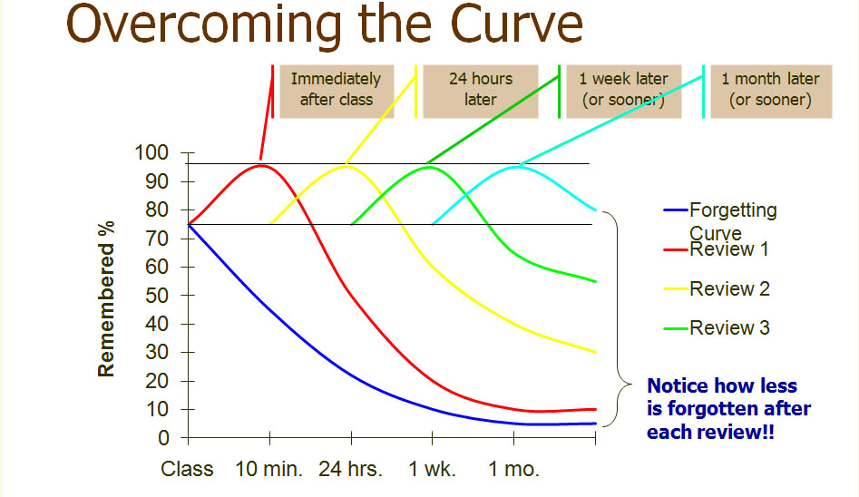
For a more scientific perspective on the “Forgetting Curve”: https://psychology.stackexchange.com/questions/8377/how-are-these-review-forgetting-curve-calculated

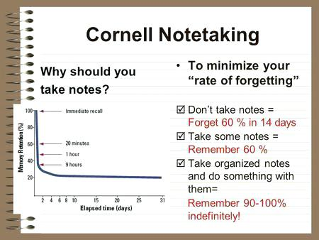
The quicker you return to a lesson to review it, the less time you will need to gently nudge it into your long-term memory, so 5 minutes of work within the first 24 hours can be as effective as an hour of study a month later. Remember, your brain does not understand what you are trying to do, but if you try to work with it, and help it along, remind it that this stuff matters to you (and it), it will be more likely respond in the way that you want and learn what you need it to.
Effective learning is essentially effective brain programing, and the Cornell Notetaking System is a highly efficient (more learning in less study time) way to insert new ideas, skills and understanding into your long term memory.
你越早回顾课程内容，就越不需要花费太多时间将其逐步植入长期记忆。因此，在最初24小时内花5分钟复习的效果，可能相当于一个月后学习一小时的效果。记住，你的大脑并不理解你正在做什么，但如果你尝试与它互动，引导它，并提醒它这些内容对你（以及它自身）都很重要，它就更有可能按照你想要的方式做出反应，并学习你需要的东西。
有效的学习本质上就是有效的脑部编程，而康奈尔笔记系统是一种高效（用更少的学习时间学习更多内容）的方法，可以将新的想法、技能和理解植入你的长期记忆。

Cornell Notetaking – What to do and Why it Helps
Notetaking has been an essential skill that the most important and prominent minds throughout history have used to record, explore and expand their thinking. Perhaps the most famous notes were those of Leonardo da Vinci, which shows how he interconnected his then advanced ideas on science and the human body with his mastery of visual art and profound insights into design.
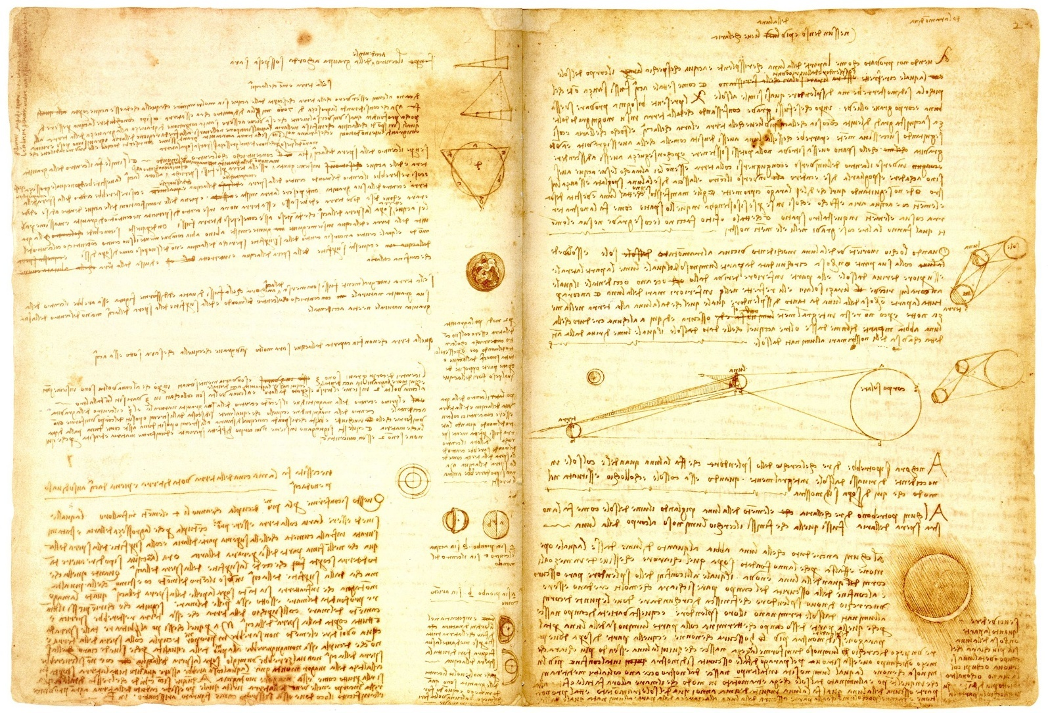
Leonardo da Vinci’s notes in the Codex Leicester, above, and sketches from his anatomical sketches, below, held in the Royal Collection. For a boss-level free book in .pdf format on DaVinci’s anatomical sketches:
https://www.rct.uk/collection/publications/leonardo-da-vinci-anatomist
For more resources on notes and why they matter at iGCSE and AS/A2 levels and beyond, including exemplar notes from students and a PowerPoint presentation exploring the value of notetaking skills see www.SmashingScience.org
康奈尔笔记法——如何做笔记以及它为何如此重要
笔记一直是历史上最重要、最杰出的思想家们用来记录、探索和拓展思维的重要技能。其中最著名的笔记或许要数列奥纳多·达·芬奇的笔记了，这些笔记展现了他如何将当时先进的科学和人体理论与他对视觉艺术的精湛掌握以及对设计的深刻见解融会贯通。
上图为列奥纳多·达·芬奇在莱斯特手稿中的笔记，下图为他收藏于英国皇家收藏的解剖草图。如需获取一本关于达·芬奇解剖草图的精深免费PDF电子书，请访问：
https://www.rct.uk/collection/publications/leonardo-da-vinci-anatomist
如需更多关于笔记及其在iGCSE、AS/A2及更高阶段学习中的重要性的资源，包括学生笔记范例和探讨笔记技巧价值的PPT演示文稿，请访问www.SmashingScience.org
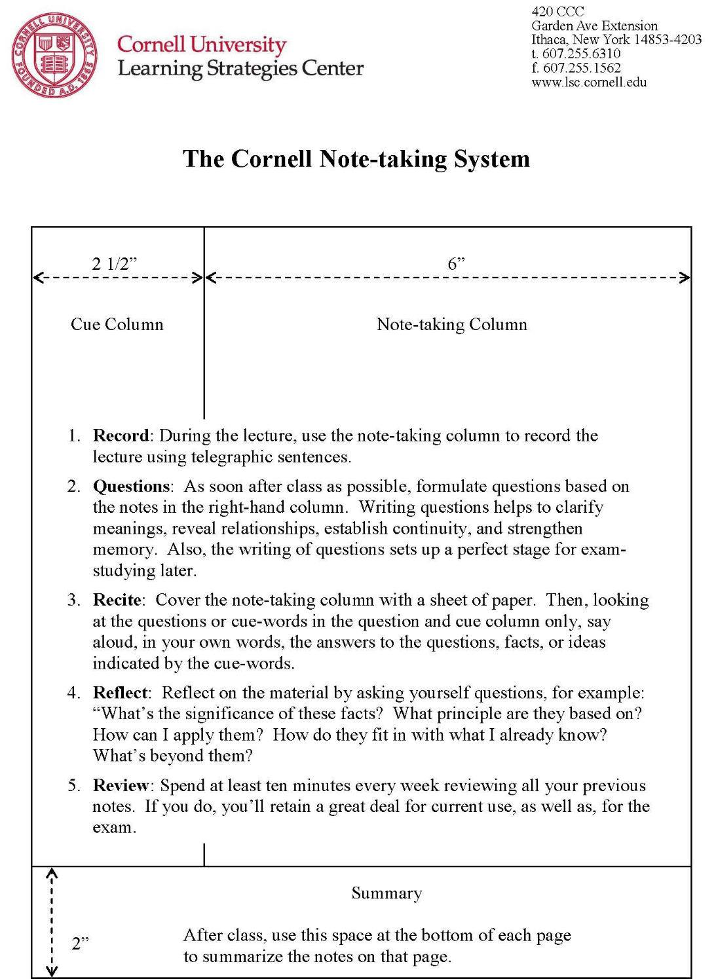
https://lsc.cornell.edu/how-to-study/taking-notes/cornell-note-taking-system/
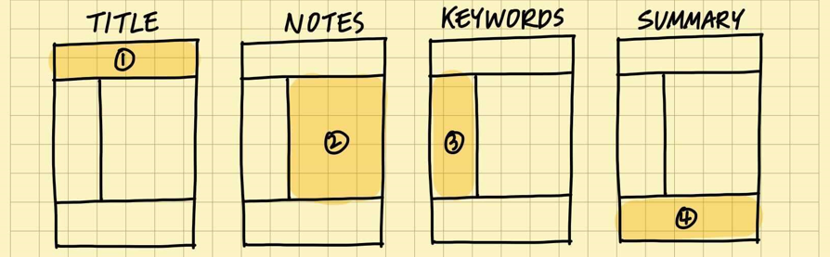
Order to complete notes, start with the title (#1). The last section (#4) is done after at least one full night’s sleep.
完成笔记的顺序是：从标题（#1）开始。最后一部分（#4）至少要在睡足一晚之后才能完成。
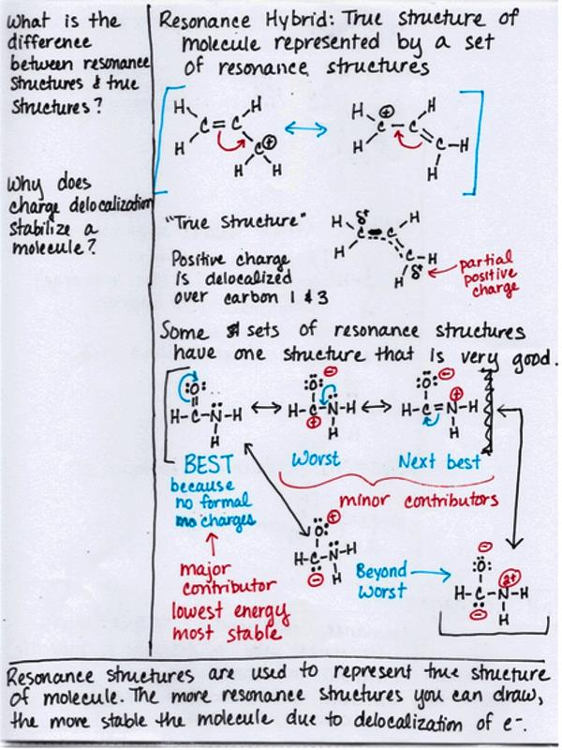

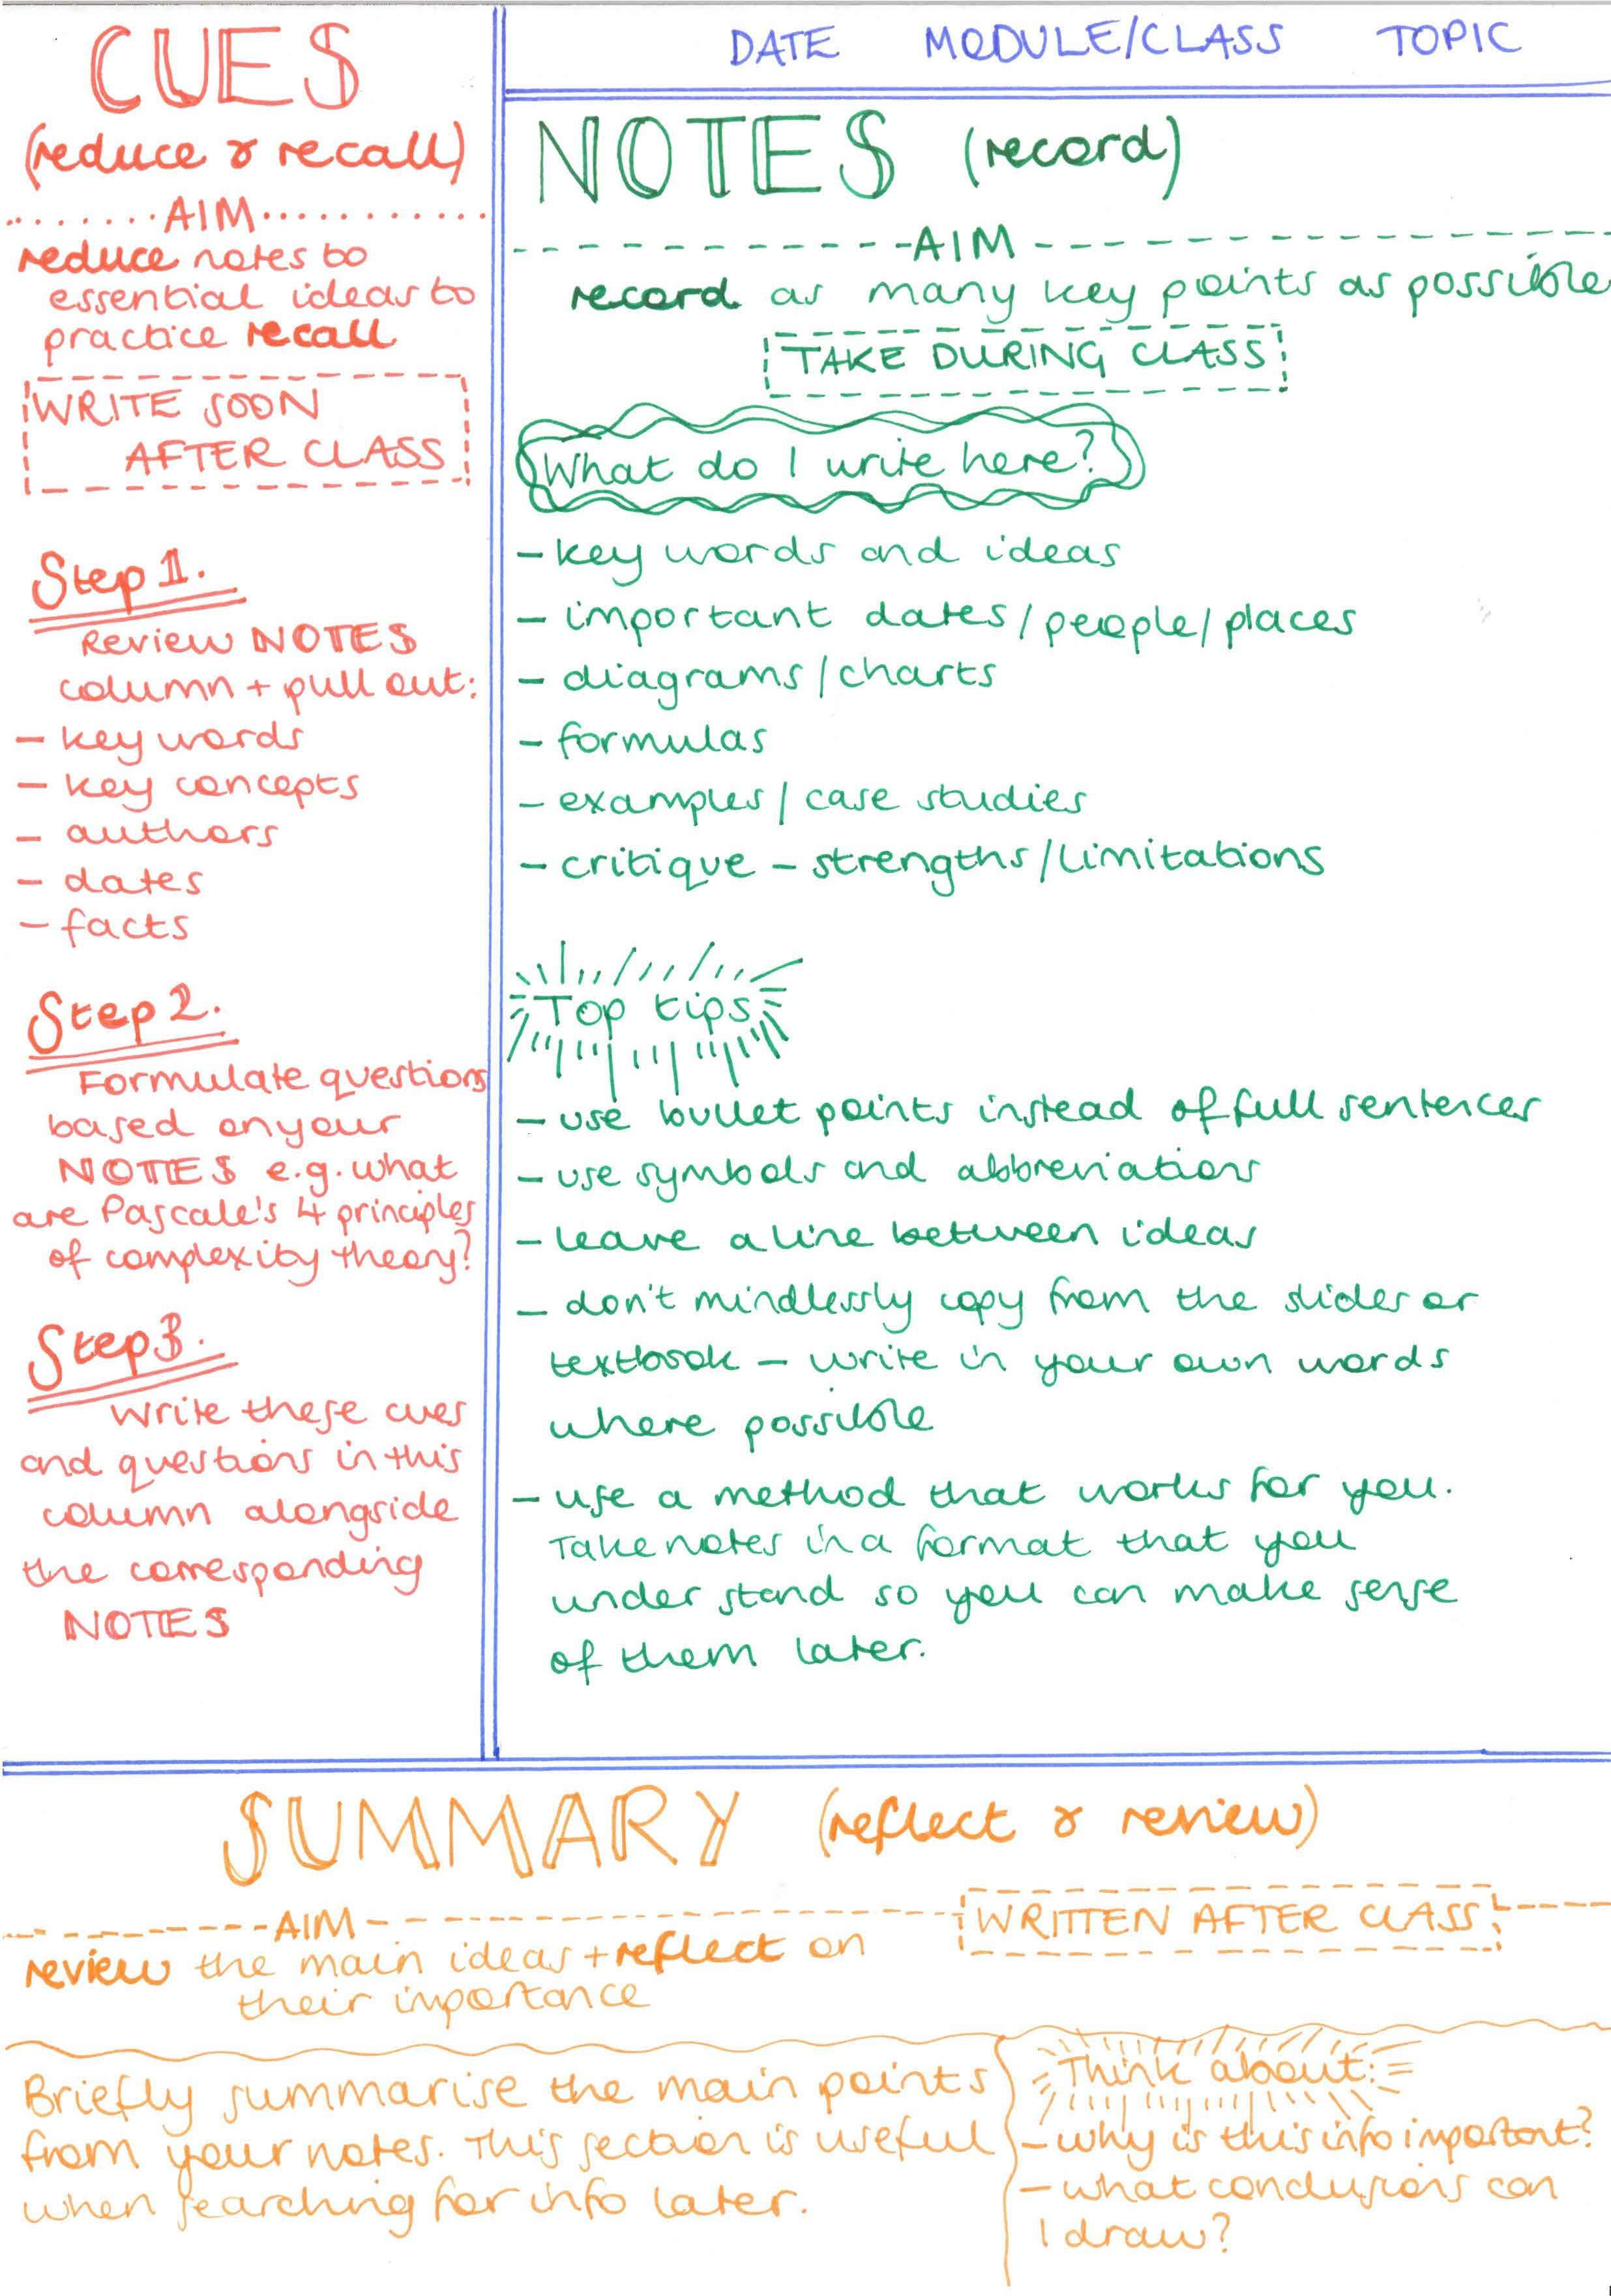
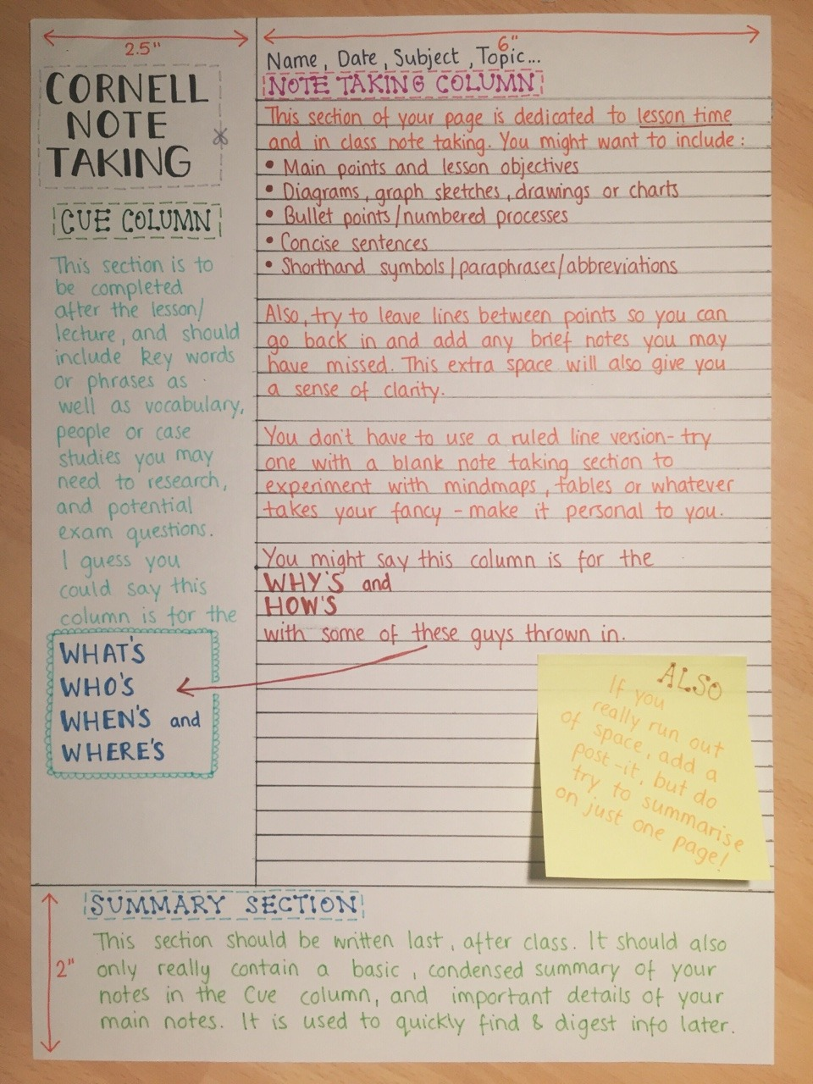
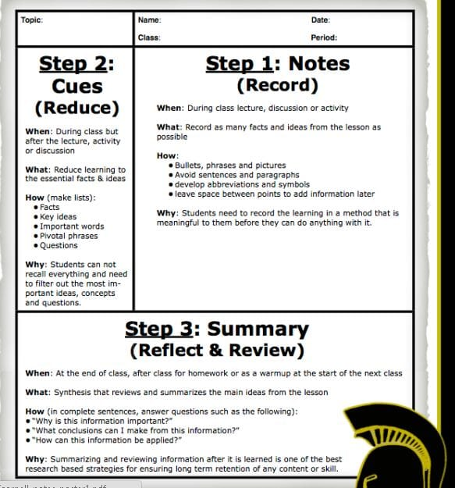

Exercise: Learning and Understanding the Five R’s of the Cornell Notetaking
Use the table of ideas in the section “Learning with your Textbook using Active Learning and Active Reading” to actively read the living heck out of the descriptions of what highly effective Cornell Notetaking looks like, and the explanations about why it works so well that follow.
On a piece of paper marked out with the Cornell Notetaking sections, write out as much of these details, instructions and explanations about the Cornell Notetaking System as you can remember, write them in the most effective place, using as much details as you can remember. Then re-read these descriptions and explanations here and add to your notes the things you think are important, but that you missed.
Extension activity: You can create an A3 version (or larger) with all of the details, an A4 version with the most important, and A5 and A6 versions which progressively include stronger and more succinct summaries.
Regularly and Systematically Reflecting to Make Progress Deliberate: At the start of every term, try to recreate this page summarising and listing key points of the Cornell Notetaking from memory, then check with the one you created last term. Also, read again the notes in this workbook and think about what you tried that works best, what you could improve, either by upgrading something you are already doing, or by trying something new to you. Add these additions and changes to improve and update the working version of your own most important ideas on effective Cornell Notetaking. Keep this version with you at the start and try to implement the new ideas as early and as often as possible into you class notes.
The Five R’s of the Cornell Notetaking – Summary
- Record – Your notes (ideally in your own words), written in class, with as much detail as you have time to include, written in the largest, main space.
- Reduce – Extract keywords, chemical symbols, structures, diagrams and equations, create questions which your notes may or may not answer, done after the main part of the lesson, or after the lesson on the same day.
- Recite – Cover your notes, read out loud your que column, then your notes. Maybe even record your performance.
- Reflect – Create 1 or 2 summary sentences that includes only the most essential and important ideas from that lesson.
- Review – Return to your notes, build on and add to them. Reread your summaries regularly, especially before solving past exam paper questions on the topic.
练习：学习和理解康奈尔笔记法的五大要素

使用“运用主动学习和主动阅读法学习教材”部分中的概念表格，认真阅读并仔细理解高效康奈尔笔记法的描述及其背后的原理。

在一张标有康奈尔笔记法各部分的纸上，尽可能详细地写下你所能记住的关于康奈尔笔记法的细节、说明和解释，并尽可能地将它们写在最有效的地方。然后，重新阅读这些描述和解释，并将你认为重要但遗漏的内容添加到你的笔记中。

拓展活动：你可以制作一个包含所有细节的A3版本（或更大尺寸），一个包含最重要内容的A4版本，以及A5和A6版本，逐步添加更精炼、更简洁的总结。

定期系统地反思以取得进步：每个学期开始时，尝试凭记忆重新整理此页面，总结并列出康奈尔笔记法的关键要点，然后与上学期整理的版本进行核对。此外，再次阅读本练习册中的笔记，思考哪些方法最有效，哪些可以改进，无论是改进现有方法还是尝试新方法。将这些补充和修改添加到练习册中，以改进和更新你关于高效康奈尔笔记法的最重要想法。将这个版本放在你身边，并尽可能早地将新想法应用到你的课堂笔记中。

康奈尔笔记法的五大要素——总结

1. 记录——在课堂上用你自己的话记录笔记，尽可能详细地记录，并写在最大的主页面上。

2. 精简——提取关键词、化学符号、结构式、图表和方程式，并提出一些问题，这些问题可能与你的笔记内容相关，也可能不相关。这项工作可以在课程的主要部分结束后，或者当天课程结束后完成。

3. 复述——遮住你的笔记，大声朗读你的问题栏，然后再朗读你的笔记。你甚至可以录下你的朗读过程。

4. 反思——用一到两句话概括这节课中最核心、最重要的知识点。

- 复习——回顾你的笔记，并在此基础上进行补充和完善。定期重读你的总结，尤其是在解答相关主题的往年试题之前。

Learning and Understanding the Five R’s of the Cornell Notetaking
  - RECORD the ideas of the lesson by handwriting them in the large right-hand section.
    - Writing them out combines the thinking that uses the part of your brain associated with the idea, and with the part of the brain with the incredibly complex fine motor hand skills that creates handwriting; typing uses fewer muscles, so less brain action, so less effective. The best notes are those that you have created yourself, even if you have only altered the word order; the more you have to think, the deeper the idea goes into the brain.
    - This should be done in the lesson.
    - These notes should be as complete as possible.
    - Try to leave large spaces, at least 30% for future notes to be added later.
    - Use a variety of colours. A single pen with 4 colours is extremely valuable to professional notetaking. Try to think of a system to highlight increasingly important terms , e.g. black, least important, blue, green then red, most important keywords, with red CAPITALS BOLD UNDERLINED the most important you have seen this whole week. You will need to think slightly more as you are writing them, comparing new information with what you have already written on this page, and if its extremely important, other pages elsewhere. Your notes will also look much more appealing and easier to use when you are under stress preparing for an important test. Great notes are a kind gift to your future self. When you ever see your bad notes that are poorly presented, which are hard to read and all of a single colour without any formatting or attempts to help you see what matters most, is a great moment to decide to buy a 4 colour pen and start using it!
    - If English is not your first language, include translations here.
学习和理解康奈尔笔记法的五大要点
1. 将课程要点手写在右侧大区域。
a) 手写笔记结合了大脑中与该要点相关的思考区域和负责书写的精细手部动作区域；打字使用的肌肉较少，大脑活动也较少，因此效率较低。最好的笔记是你自己创建的，即使你只是改变了词序；思考越多，对要点的理解就越深入。
b) 应该在课堂上进行记录。
c) 笔记应该尽可能完整。
d) 尽量留出较大的空白，至少30%，以便日后添加笔记。
e) 使用多种颜色。一支四色笔对于专业的笔记记录来说非常有用。尝试设计一个系统来突出显示越来越重要的术语，例如：黑色代表最不重要，蓝色、绿色和红色代表最重要的关键词，其中红色粗体大写下划线标注的是你本周看到的最重要的信息。你需要在记录时多加思考，将新信息与你已记录在本页上的内容进行比较，如果信息极其重要，还可以参考其他页面上的内容。这样，你的笔记在准备重要考试的压力下也会显得更加美观易用。一份好的笔记是送给未来自己的一份厚礼。当你看到自己那些排版糟糕、难以阅读、只有一种颜色、没有任何格式或辅助说明的笔记时，正是决定购买一支四色笔并开始使用它的好时机！
f) 如果英语不是你的母语，请在此处添加翻译。
  - REDUCE the sentences from your notes into just a few keywords and ideas into the much smaller cue column.
    - This helps crosslink the parts of your brain that creates handwriting with the parts of your brain responsible for creative, analytical and critical thought, which helps to use and grow your higher order thinking skills on this subtopic, and in general. Your brain is required to see different ideas and rank their importance, so has to compare them with each other and the idea in general. The thinking it is required to do this actually creates new physical connections inside your brain.
    - This should be done some time, either minutes or hours, after your notes were made and on the same day (before you sleep).
    - If these notes are done really well you will be able to put a blank page over your main notes and from just reading the que column on the left you will be able to recall not only keywords, but the whole idea, which makes revision much more effective and faster to do.
    - Try to leave large spaces, at least 30%, for future notes to be added later.
    - If English is not your first language, include key translations here.
2. 将笔记中的句子精简成几个关键词和想法，并将它们添加到更短的提示栏中。
a) 这有助于将大脑中负责书写的部分与负责创造性、分析性和批判性思维的部分连接起来，从而帮助你在这个子主题以及更广泛的范围内运用和提升高阶思维能力。你的大脑需要识别不同的想法并对其重要性进行排序，因此它必须将它们相互比较，并与整体想法进行比较。这种思考过程实际上会在你的大脑内部建立新的物理连接。
b) 这项工作应该在记笔记后的一段时间内完成，可以是几分钟或几小时，并且应该在当天完成（睡觉前）。
c) 如果这些笔记做得非常好，你可以在主要笔记上放一张空白页，然后仅通过阅读左侧的提示栏，你不仅可以回忆起关键词，还可以回忆起整个想法，这使得复习更加高效快捷。
d) 尽量留出较大的空白，至少30%，以便日后添加笔记。 e) 如果英语不是您的母语，请在此处提供关键翻译。
  - RECITE, or read out loud the words in the recall column.
    - Speaking out these keywords and essential ideas combines the thinking parts of the brain needed for these ideas with another incredibly complex region of the brain involved with the throat, mouth, tongue and lips that produces spoken language and speech. It might feel like this doesn’t make a difference, but it really does.
    - This is especially useful for English as an additional language learners.
    - Cover first your main notes and just read the que column.
    - Describe diagrams with words.
    - Try to record your performance, especially for the harder topics. This can improve your confidence in public speaking, which is a key life skill. You edit these together and have your own personal podcast of your voice and your notes about key topics. The process of creating these files will also introduce you to an entirely new skillset connected to content generation.
    - This can be done really quickly and without much effort several times before your topic test or exam, but ideally only once per session, with sleep between each session, which helps consolidate and reinforce learning in extremely effective ways.
    - Your notes will be at their most advanced state and useful when you have finished the topic in class, read through the textbook and completed all of the exercises associated with the chapter suggested in this workbook and are preparing for the end of topic test or an exam. They will hopefully include a great deal of updates, and upgrades, that are also easy and quick to identify. Reading these notes calmly and deliberately, thinking about what you are saying, just before the exam will pull together all of the hard work you have done at different times and in different ways activating all of the memories you have worked so hard and so carefully to create.
    - Listening to your notes could be an interesting and strongly different new way to revise in the future, find out if it works for you!
3. 复述，或大声朗读回忆栏中的文字。
a) 说出这些关键词和核心概念，能将大脑中负责思考这些概念的区域，与大脑中另一个极其复杂的区域（负责喉咙、口腔、舌头和嘴唇，从而产生口语和言语）结合起来。你可能觉得这没什么区别，但实际上意义重大。
b) 这对以英语为第二语言的学习者尤其有用。
c) 先遮住你的主要笔记，然后只阅读问题栏。
d) 用文字描述图表。
e) 尝试录制你的表现，尤其是对于较难的主题。这可以提高你公开演讲的自信心，而公开演讲是一项重要的生活技能。你可以将这些录音剪辑在一起，制作你自己的个人播客，其中包含你的声音和关于关键主题的笔记。创建这些文件的过程也会让你接触到一套与内容创作相关的全新技能。
f) 在单元测试或考试前，可以多次快速轻松地完成这项练习，但理想情况下，每次练习只需一次，每次练习之间留出睡眠时间，这样有助于以极其有效的方式巩固和强化学习。
g) 当你完成课堂学习、通读教材、完成本练习册中建议的所有章节练习，并准备单元测试或考试时，你的笔记将处于最佳状态，也最有用。此时，笔记中应该包含大量更新和改进，而且这些更新和改进也很容易快速识别。在考试前，冷静而认真地阅读这些笔记，思考你正在阅读的内容，可以将你之前在不同时间以不同方式所做的所有努力融会贯通，激活你辛勤努力、精心构建的所有记忆。
h) 听笔记可能是一种有趣且截然不同的复习方式，不妨试试看它是否适合你！
  - REFLECT on the ideas and the connections needed to understand the concept by creating summary sentences.
    - By creating just 1 or 2 summary sentences you will be making your brain go through the whole lesson’s worth of ideas again, but this time after it has been allowed to sleep, which causes important changes to its abilities and allows it to remember better. You will also have to think critically and logically to remove as much as possible to allow the central ideas to remain complete, and leaving out everything that might be important, but not essential. Writing interlinks these higher order thinking skills with the complex physical action of writing, helping embed these ideas even further into your long-term memory.
    - When reflecting, try to organise the information in a new way. So create a reveres time order for a process, or if your notes go from small to large in your notes, do the reverse order in your summary.
    - You need to do this after you have slept well, ideally about a week after the lesson.
    - When done well, another revision strategy would be to put a paper across the top 80% of your notes and only read these summary sections. Then on that paper write out whatever is important but missing from the summary. Check with your cue section and then your notes to see if there is anything really important that you would have liked to include and then write out as succinctly as possible onto a strip of paper. Tape those new notes to the summary section to use later.
    - Try to leave large spaces, at least 30% for future notes to be added later.
4. 通过撰写总结句来反思理解概念所需的想法和联系。
a) 只需撰写一到两句总结句，就能让你的大脑再次回顾整节课的内容，但这次是在睡眠之后进行的，睡眠能显著提升大脑的记忆能力，使其记忆更清晰。你还需要进行批判性和逻辑性思考，尽可能地精简内容，保留核心思想，并剔除所有可能重要但并非必要的信息。写作将这些高阶思维技能与复杂的书写动作结合起来，有助于将这些想法更牢固地植入你的长期记忆中。
b) 反思时，尝试用新的方式组织信息。例如，对某个过程进行时间倒序排列；或者，如果你的笔记是从小到大排列的，那么在总结中也采用相反的顺序。
c) 你需要在睡个好觉之后进行这项工作，理想情况下是在课后一周左右。
d) 如果方法得当，另一种复习策略是：用一张纸覆盖笔记顶部80%的内容，只阅读这些总结部分。然后在纸上写下总结中遗漏的重要信息。对照提示部分和笔记，看看是否有任何你想要添加的重要内容，然后尽可能简洁地写在一张纸条上。把这些新笔记贴到总结部分，以便日后使用。
e) 尽量留出较大的空白，至少30%，以便日后添加笔记。
  - REVIEW your notes immediately and regularly using past exam paper questions. Add to them whenever you notice something important missing.
    - The best way to test your understanding of your notes is past exam papers, which is why this Workbook exists. Almost all of the most effective and deepest learning will be done with past exam questions, both answering them, and especially checking those answers carefully with the mark schemes. The most successful students at the most selective universities are all experts at exam technique and exam questions. They are also incredibly well organised because the kinds of things that are in this Workbook are part of their everyday high school life, in their tutor time, and their lessons. But anyone can learn these key organisation, notetaking and exam skills.
    - Trying to answer a question on your own is the best way to really test yourself. Guess if you have to, but the more you write, the better your guessing skills will get (which eventually, with a lot of structured growth, becomes what is known as “Professional Judgement”, which is how engineers, for instance build a new kind of aeroplane). Also, the more invested you are in trying to find the answer, by writing as much as you know, the more interested you will be to know the actual correct and complete answer.
    - Finding questions that you can’t quite answer on your own when you are solving past exam questions will give you the most valuable study aid there is: a practical curiosity to find out.
    - After you have got as much written down as you can using only your memory, check you notes for questions you think need more than you are able to remember. In a different colour pen, add to your answer using information in your notes.
    - After completing about 10 to 20 mark’s worth of questions (or a page or two from this Workbook), check your answers with the mark scheme. You should be able to easily tell which answers you were able to remember on your own, and what parts you got from your notes because they are written in a different colour pen. In a third colour, ideally red, add additional details until your answer includes all of the points needed to get all of the marks in the mark scheme.
    - The details you remembered without help are least important to getting the next grade: you already know them and have shown that you can deliver them in the right context.
    - The details you needed your notes for are the most important for you getting the higher grade. You have already started the work to learn these and can use them effectively when they are in front of you. You just need to remember them better. These are usually the easiest but most important and most valuable details to learn for the next test. You can write these on cue cards or flashcards to help you remember them better, for instance.
    - The details you could not remember and did not include from your notes but were in the mark scheme have two categories. Both of these levels represent the hardest parts of the syllabus to you.
      - If the detail was in your notes, but you did not include it, where was it?
      - Was it in your main notes, the cue column, or the summary section at the bottom?
      - How can you highlight this detail?
      - Usually given that you missed it, even with your notes in front of you, it means you should give it an increased level of priority, so either promote it by writing it out into the cue column from the main notes section or even adding it the summary section (the most important part).
    - If the details from the mark scheme you missed were not in your notes, where they in the textbook?
      - Tracking down these details is your curiosity in action, and this is the most powerful way to learn.
      - If you find these kinds of details are often in the textbook, but not your notes after you have finished learning a topic in class then you need to fill in these gaps.
      - The easiest way to do this is to use a textbook find out what you are missing and add it afterwards to each topic.
      - The most effective way to do this is to try to find out why you are missing out on these key facts in your notes and solve the problem, either by making better notes in class, if that is where the problem is coming from.
      - Or, if you are getting everything written down in class, but there are still key things missing, then after each class add to your notes using the relevant sections of your textbook.
    - After every topic test, look back on your notetaking method and make improvements to address whatever issues you have encountered. If you need more space, miss every other or every third line out. If your notes in class are too messy to easily read, rewrite them after class but on the same day after you made them (an extremely powerful technique, but usually not as effective for most students as solving past exam questions).
5. 立即并定期使用往年试题复习笔记。一旦发现遗漏的重要内容，就及时补充。
a) 检验笔记理解程度的最佳方法是使用往年试题，这也是本书存在的意义。几乎所有最有效、最深入的学习都将通过往年试题来实现，包括解答试题，尤其是仔细对照评分标准核对答案。顶尖大学中最成功的学生都是考试技巧和试题方面的专家。他们也极其善于组织，因为本书中的内容正是他们高中生活、辅导课和课堂学习中不可或缺的一部分。但任何人都可以学习这些关键的组织、笔记和考试技巧。
b) 尝试独立解答问题是真正检验自己能力的最佳方法。必要时可以猜测，但你写的越多，你的猜测能力就会越强（最终，经过系统性的训练，这将发展成为所谓的“专业判断力”，例如，工程师就是凭借这种能力来设计新型飞机的）。此外，你越投入地尝试寻找答案，尽可能多地写下你所知道的内容，你就越会渴望知道真正正确完整的答案。
c) 在解答往年考题时，找到那些你无法独立解答的问题，会为你带来最宝贵的学习辅助：一种想要探究的好奇心。
d) 在你尽可能多地仅凭记忆写下答案后，检查你的笔记，找出那些你认为需要更多信息才能回答的问题。用另一种颜色的笔，根据笔记中的信息补充你的答案。
e) 完成大约10到20分的题目（或这本练习册的一两页）后，对照评分标准检查你的答案。你应该能够轻松地分辨哪些答案是你独立记住的，哪些部分是从笔记中得到的，因为它们是用不同颜色的笔写的。用第三种颜色，最好是红色，添加更多细节，直到你的答案包含评分标准中所有必要的要点，从而获得全部分数。
f) 那些无需帮助就能记住的细节对获得更高分数来说最不重要：你已经掌握了这些细节，并且已经证明你能在合适的语境中运用它们。
g) 那些需要查阅笔记才能记住的细节对你获得更高分数至关重要。你已经开始学习这些细节，并且能够在需要时有效地运用它们。你只需要更好地记住它们。这些通常是最容易记住但又最重要、最有价值的细节，值得你为下次考试做好准备。例如，你可以把它们写在提示卡或记忆卡片上，以帮助你更好地记住它们。
h) 那些你记不住且没有从笔记中提及，但评分标准中却包含的细节分为两类。这两类细节都代表了你认为课程大纲中最难的部分。
i. 如果这个细节在你的笔记中，但你没有记下来，它在哪里？
ii. 它在你的主要笔记、提示栏还是底部的总结部分？
iii. 你如何突出这个细节？
iv.通常情况下，如果你即使笔记就在眼前仍然错过了某些内容，那就意味着你应该更加重视它。你可以把它从主笔记中摘录出来，写到提示栏里，或者添加到总结部分（最重要的部分）。
i) 如果你的笔记里没有评分标准中的细节，那么课本里有吗？
i. 寻找这些细节体现了你的好奇心，这是最有效的学习方法。
ii. 如果你发现这类细节经常出现在课本里，但在课堂学习完某个主题后，你的笔记里却没有，那么你需要填补这些空白。
iii. 最简单的方法是查阅课本，找出你遗漏的内容，然后将其添加到每个主题中。
iv. 最有效的方法是找出你为什么会遗漏这些关键信息，并解决这个问题。如果问题出在课堂笔记上，那就需要改进课堂笔记。
五、或者，如果你在课堂上记下了所有内容，但仍然遗漏了一些关键信息，那么每次课后，都可以参考教材的相关章节来补充笔记。
六、每次单元测试后，回顾一下你的笔记方法，并针对遇到的问题进行改进。如果需要更多空间，可以隔行或隔两行省略。如果课堂笔记过于杂乱，难以阅读，可以在课后当天重写一遍（这是一种非常有效的技巧，但通常对大多数学生来说不如做往年真题有效）。

Using the Cornell Notetaking System for Topics you have not Studied in Class

You can also use the Cornell Notetaking system to make notes from chapters you have not studied in class. To study well doing that you should be rewriting the ideas found in the textbook into your own words, the more you change what was written the stronger the learning effect. If you are going to cover this topic anyways in class, this kind of activity often is not a particularly effective or efficient use of study time.
Some students will race ahead and do work on topics much later in the AS syllabus, including into the A2 syllabus, sometimes without really looking into the past exam questions for the topics they already feel they have completed. This is often not the best use of time to get the highest quality A*. Vital understanding that is needed to make sense of this more advanced material is often missing, leading to silly misunderstandings which are hard to unlearn. It is far better instead to become a true expert on the topic you are studying, and any you have studied, with past exam paper questions especially, and then working on and exploring every other active learning technique presented in these workbooks.
More information can be found here: https://www.smashingscience.org/uni-guidance
使用康奈尔笔记法复习课堂未学内容
你也可以使用康奈尔笔记法来记笔记，记录课堂未学过的章节内容。为了更好地学习，你应该用自己的语言重述课本中的观点，你对原文的改写越多，学习效果就越好。如果你无论如何都会在课堂上学习这些内容，那么这种学习方式通常不是特别有效或高效的。
有些学生会急于求成，提前学习AS课程大纲中较晚的内容，甚至包括A2课程大纲中的内容，有时甚至没有认真查看他们自认为已经掌握的内容的往年考题。这通常不是获得最高分A*的最佳方法。理解这些更高级内容所需的关键知识往往缺失，导致一些难以纠正的低级误解。与其如此，不如深入钻研你正在学习以及已经学习过的任何主题，尤其是历年真题，然后再运用和探索这些练习册中介绍的其他所有主动学习技巧。
更多信息请访问：https://www.smashingscience.org/uni-guidance

Effective Note-Taking Tips and Examples
Develop a code system of note-marking to indicate questions, comments, important points, for example:
- Mark unfamiliar vocabulary & unclear ideas in unique ways, such as with a star or asterisk.
Highlight vocabulary terms and important people.
- Circle ideas that are still unclear.
- Make sure you can understand what you have written and if needed, make corrections.
Use drawings, arrows or other organizers to help you see concepts and relationships between them.
- If you don’t understand an idea, leave a large blank space and ask your teacher, or investigate it in your textbook. Update your notes with what you found out.
- Use accepted abbreviations and symbols wherever you are comfortable
    - s/ for some: s/thing, s/where
    - Positive: +ve, +vely, Negative: -ve, -vely
    - H⁺ for proton, e⁻ for electron
    - ↓ for less, smaller or decreasing; ↑ for more, increasing or bigger
    - And is & or +Equalities and relationships: ≈approx.; ≠not the same; ≡ exactly the same; x <y x is less or x>y x is more.
    - Take particular care when writing chemical symbols and include state symbols whenever possible when you know them, so bromine is Br₂(l) not Br!
    - Always pay attention to bonding when ordering atoms in structures, so for methanol write HO-CH₃ instead of OH-CH₃ etc.
    - If your notetaking style really favours abbreviations and you find you use a larger number, make sure that you have a key page in your notes explaining what your abbreviations mean.
    - At the start of every term, spend 15 minutes to analyse your notes only for abbreviations. Do they still make sense? Do they make it harder, easier or no impact to understand your notes? Often for most students most abbreviations usually create more problems than they solve.
    - NEVER use any abbreviations except chemical elements in exam questions, either when you are practicing or in the exams!
For a more detailed and involved exploration and explanation of notetaking download document attached to this QR code (30 pages):
有效的笔记技巧和示例
建立一套笔记标记系统，用于标记问题、评论和要点，例如：
a) 用独特的方式标记不熟悉的词汇和不清楚的概念，例如用星号或星标。
突出显示词汇术语和重要人物。
b) 圈出仍然不清楚的概念。
c) 确保你能理解自己写下的内容，如有需要，请进行修改。
使用图画、箭头或其他组织工具来帮助你理解概念及其之间的关系。
d) 如果你不理解某个概念，请留出大片空白，然后询问老师或查阅课本。将你找到的信息更新到笔记中。
e) 尽可能使用你熟悉的缩写和符号。
i. s/ 表示 some：s/thing，s/where
ii. Positive：+ve，+vely；Negative：-ve，-vely
iii. H+ 表示质子，e- 表示电子
iv. ↓ 表示 less、smaller 或 reduction； ↑ 表示更多、增加或更大
v. 和是 & 或 + 等式和关系：≈ 约数；≠ 不相同；≡ 完全相同；x < y 表示 x 小于 y 或 x > y 表示 x 大于。
vi. 书写化学符号时要格外小心，尽可能在知道状态符号的情况下也写上状态符号，例如溴是 Br₂(l) 而不是 Br！
vii. 在排列结构中的原子顺序时，始终要注意键合情况，例如甲醇应写成 HO-CH₃ 而不是 OH-CH₃ 等。
viii. 如果你的笔记习惯非常依赖缩写，并且发现自己使用的缩写数量很多，请确保在笔记中留出一页关键信息页，解释这些缩写的含义。
ix. 每个学期开始时，花 15 分钟时间专门分析笔记中的缩写。它们是否仍然有意义？它们会使理解笔记变得更难、更容易还是没有影响？通常情况下，对大多数学生来说，大多数缩写带来的问题比解决的问题更多。
x. 考试题目中，除了化学元素之外，绝对不要使用任何缩写，无论是在练习还是正式考试中！

如需更详细地了解和掌握笔记技巧，请下载此二维码附带的文档（30页）：
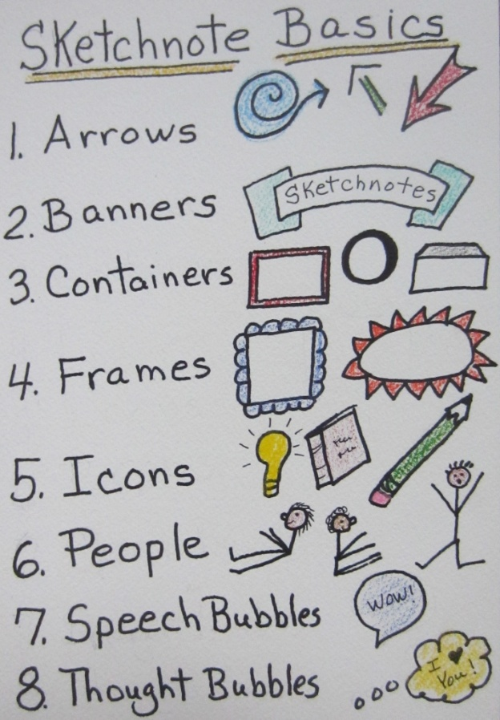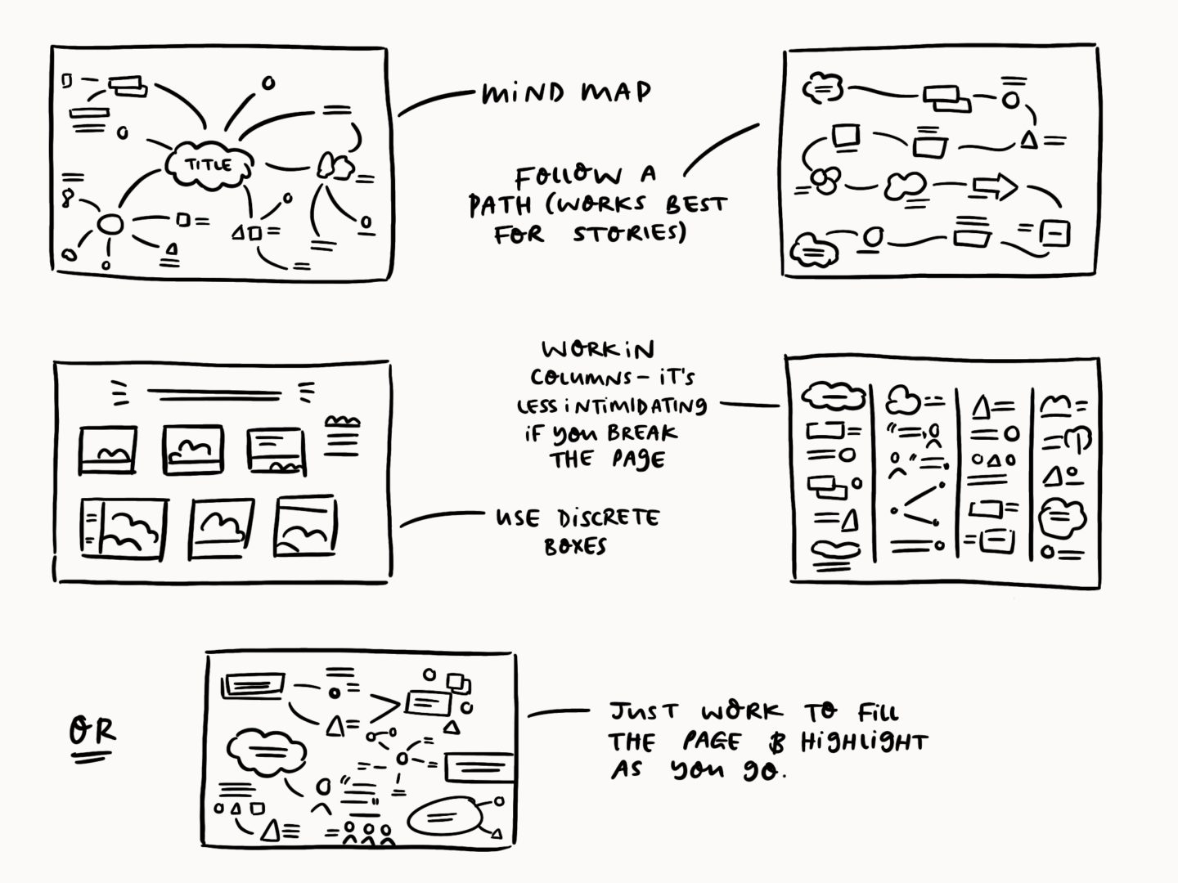
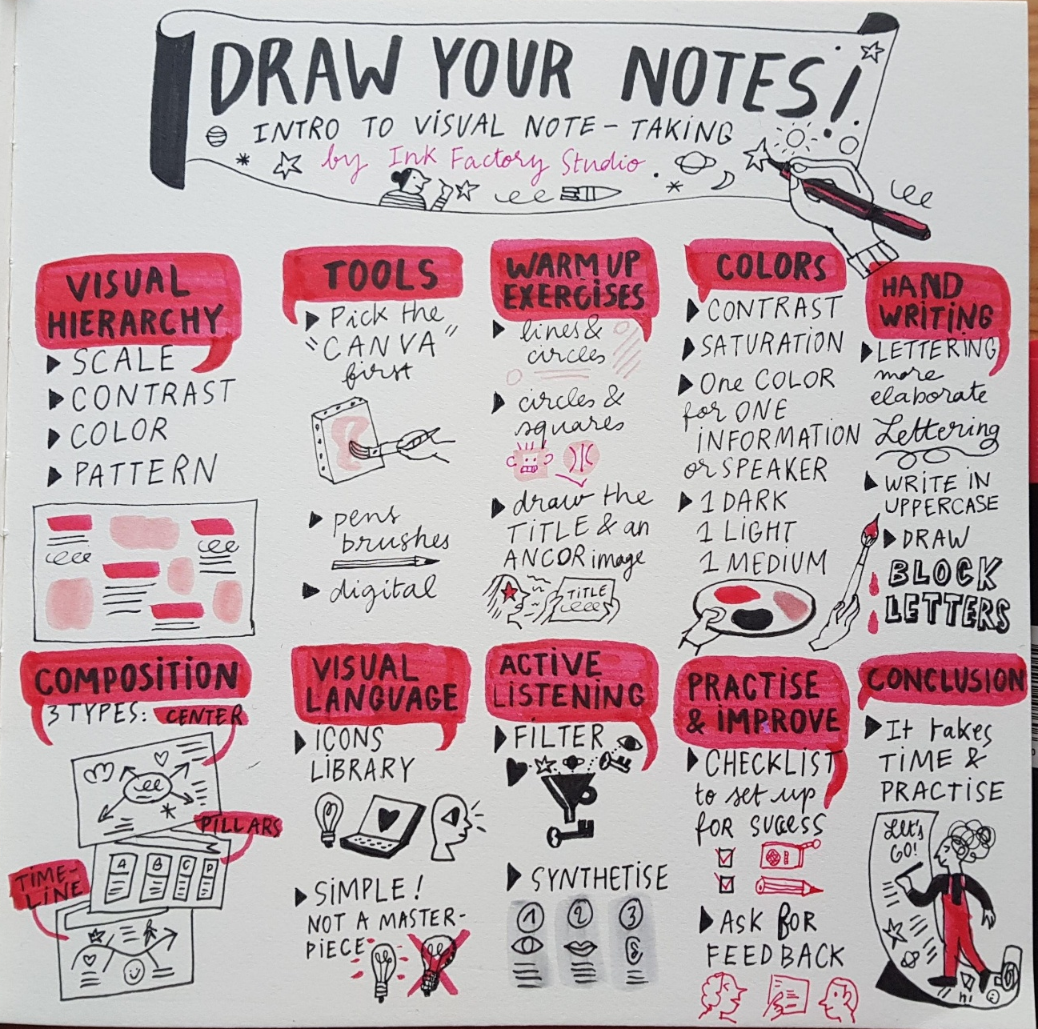
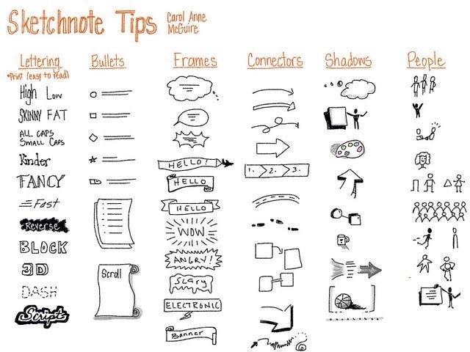

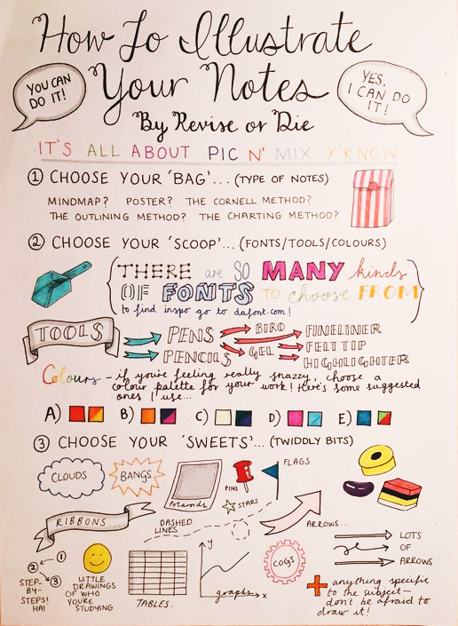
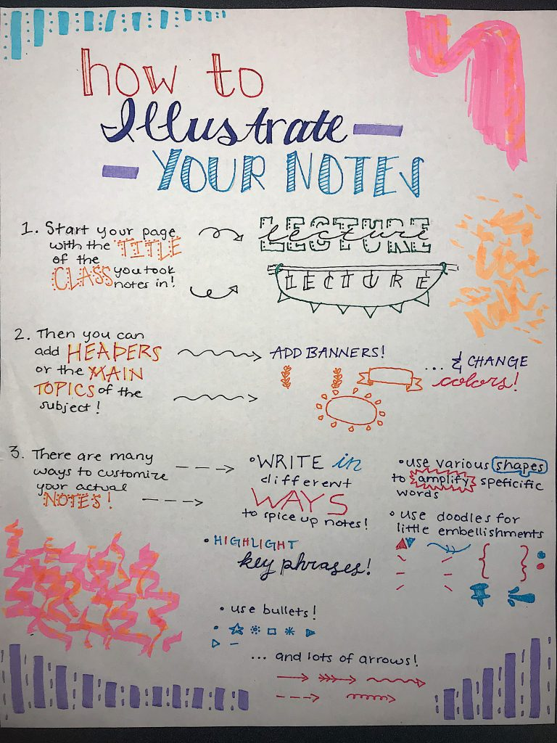
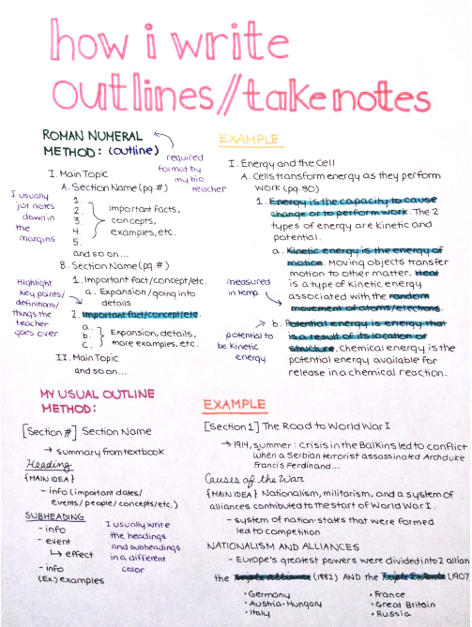

Trying Out the Cornell Notetaking System
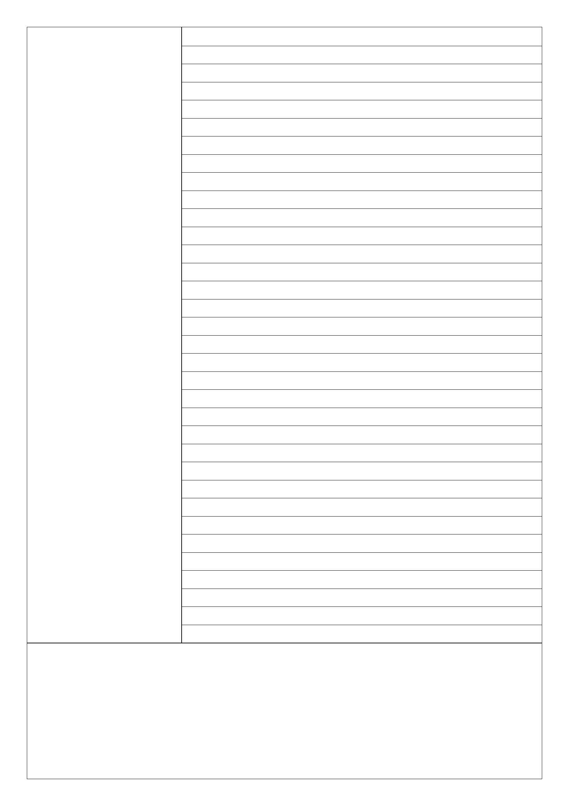
Questions & Translations
Fill this in AFTER lesson
Date:

Summary Section- Do this a week later and write, in your own words, only one or two sentences that sums up the important points on this page

For a whole variety of different formats and types of paper: https://incompetech.com/graphpaper/cornelllined/

Questions & Translations
Fill this in AFTER lesson
Date:

Summary Section- Do this a week later and write, in your own words, only one or two sentences that sums up the important points on this page

Periodic Table
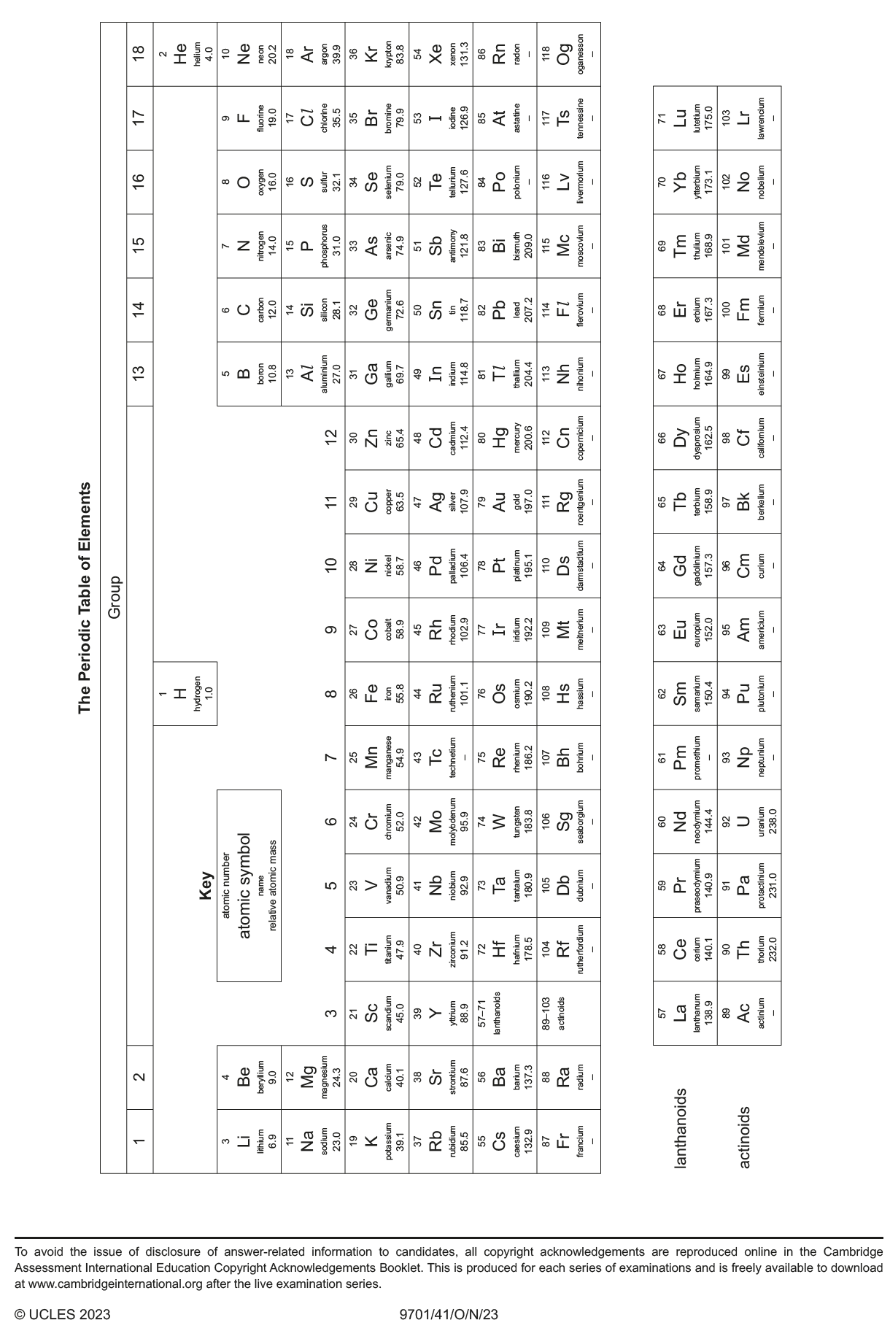

https://help.open.ac.uk/active-reading
https://teachingcommons.stanford.edu/resources/learning-resources/promoting-active-learning & https://www.smartsparrow.com/what-is-active-learning/
https://help.open.ac.uk/active-reading

