Calendars and time management
Organising your months in 2024
CAIE Chemistry 9701 A Level Chemistry Exam Timetable for Administrative Zone 5 (Time Zone 2):
Paper 1 – AS Chemistry
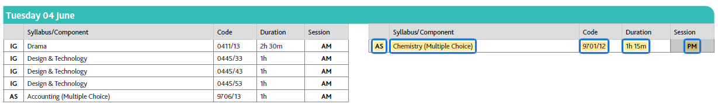
Paper 2 - AS Chemistry
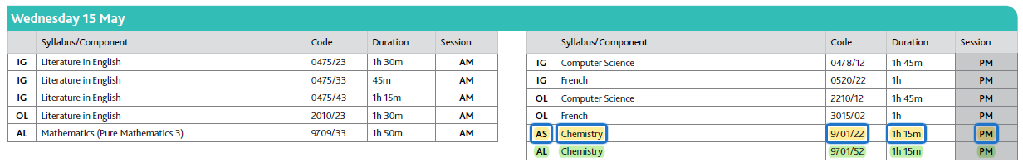
Paper 3 - AS Chemistry
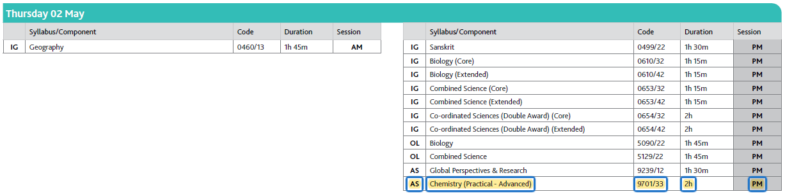
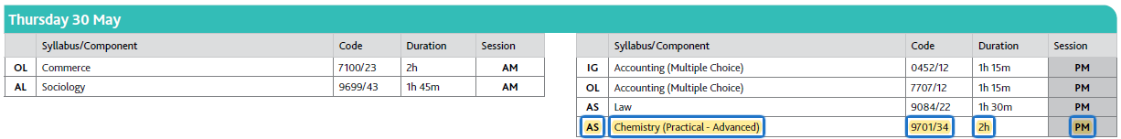
Paper 4 (A2 Chemistry)
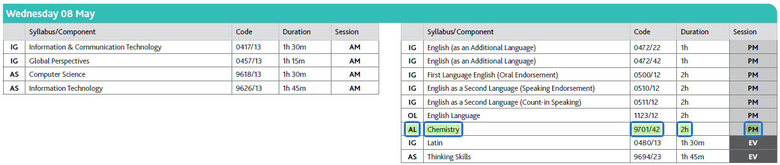
Paper 5 (A2 Chemistry)
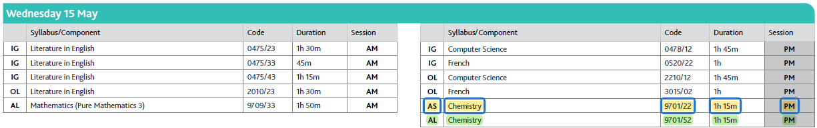
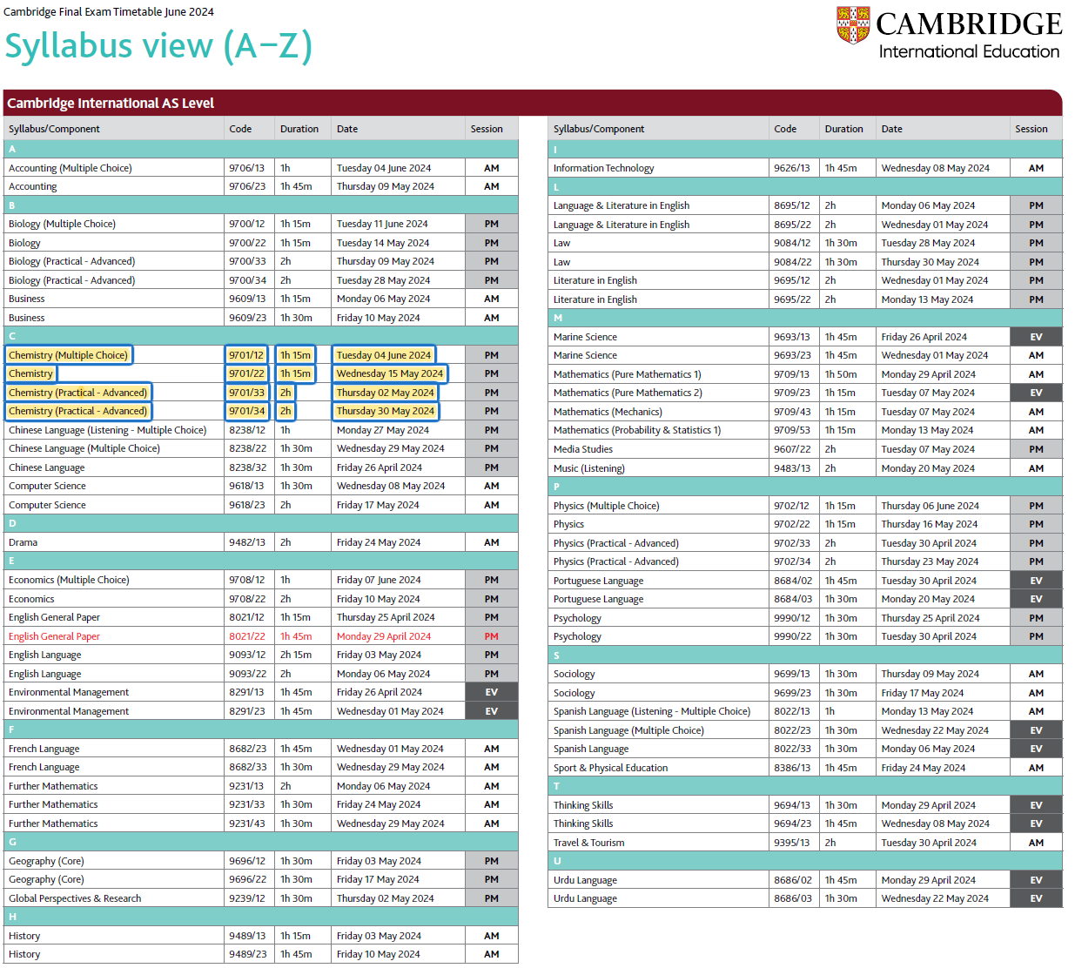
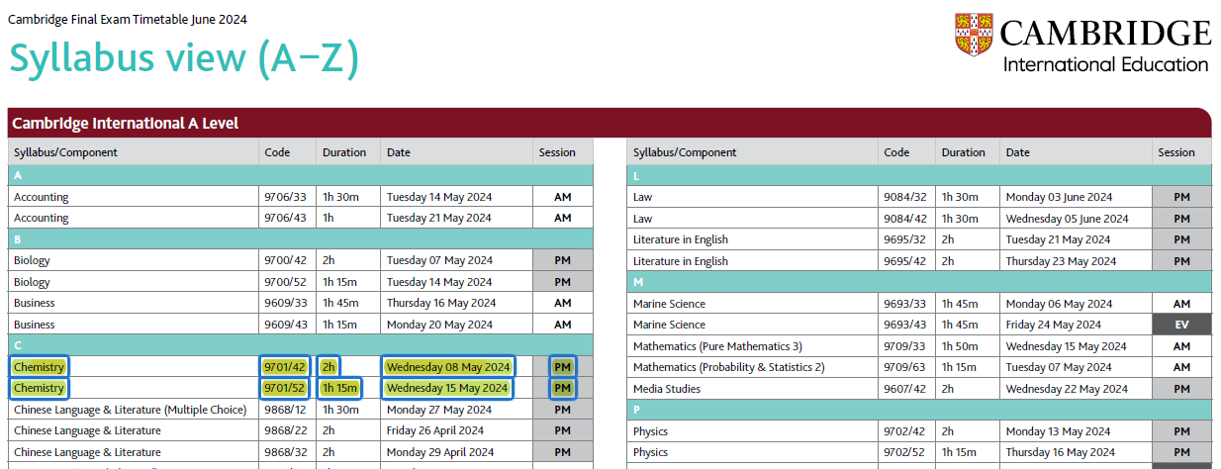
Organising your weeks
Week Starting | Wk # | Events | Topic Focus
25-Mar | 11
1-Apr | 12
8-Apr | 13 | MOCK EXAM(?)
15-Apr | 14
22-Apr | 15
29-Apr | 16 | Thur 2nd PM Paper 33 (TZ2)
6-May | 17 | Wed 8th PM Paper 4 (TZ2)
13-May | 18 | Wed 15th PM Paper 2 (TZ2)  Wed 15th PM Paper 5 (TZ2)
20-May | 11
27-May | 12 | Thur 30th PM Paper 34 (TZ2)
3-Jun | 13 | Tues 4th PM Paper 1 (TZ2)
10-Jun | 14
17-Jun | 15
24-Jun | 16

Planning your days
V1.0 – Continue to refine these to find and RECORD times you study best (and when you never study)
Period | Time | Monday | Tuesday | Wednesday | Thursday | Friday | Saturday | Sunday
 | 5:00 am
 | 5:30 am
 | 6:00 am
 | 6:30 am
 | 7:00 am
Regstn | 7:25 am
1 | 7:50 am
2 | 8:40 am
3 | 9:30 am
4 | 10:20 am
5 | 11:00 am
Lunch | 11:50 pm
6 | 1:10 pm
7 | 2:00pm
8 | 2:50 pm
9 | 3:40 pm
 | 4:20 pm
 | 5:00 pm
 | 5:30 pm
 | 6:00 pm
 | 6:30 pm
 | 7:00 pm
 | 7:30 pm
 | 8:00 pm
 | 8:30 pm
 | 9:00 pm
 | 9:30 pm
 | 10:00 pm
 | 10:30 pm
Planning your days – v2.0
Period | Time | Monday | Tuesday | Wednesday | Thursday | Friday | Saturday | Sunday
 | 5:00 am
 | 5:30 am
 | 6:00 am
 | 6:30 am
 | 7:00 am
Regstn | 7:25 am
1 | 7:50 am
2 | 8:40 am
3 | 9:30 am
4 | 10:20 am
5 | 11:00 am
Lunch | 11:50 pm
6 | 1:10 pm
7 | 2:00pm
8 | 2:50 pm
9 | 3:40 pm
 | 4:20 pm
 | 5:00 pm
 | 5:30 pm
 | 6:00 pm
 | 6:30 pm
 | 7:00 pm
 | 7:30 pm
 | 8:00 pm
 | 8:30 pm
 | 9:00 pm
 | 9:30 pm
 | 10:00 pm
 | 10:30 pm
Planning your days – v3.0
Period | Time | Monday | Tuesday | Wednesday | Thursday | Friday | Saturday | Sunday
 | 5:00 am
 | 5:30 am
 | 6:00 am
 | 6:30 am
 | 7:00 am
Regstn | 7:25 am
1 | 7:50 am
2 | 8:40 am
3 | 9:30 am
4 | 10:20 am
5 | 11:00 am
Lunch | 11:50 pm
6 | 1:10 pm
7 | 2:00pm
8 | 2:50 pm
9 | 3:40 pm
 | 4:20 pm
 | 5:00 pm
 | 5:30 pm
 | 6:00 pm
 | 6:30 pm
 | 7:00 pm
 | 7:30 pm
 | 8:00 pm
 | 8:30 pm
 | 9:00 pm
 | 9:30 pm
 | 10:00 pm
 | 10:30 pm

Planning your days – v4.0
Period | Time | Monday | Tuesday | Wednesday | Thursday | Friday | Saturday | Sunday
 | 5:00 am
 | 5:30 am
 | 6:00 am
 | 6:30 am
 | 7:00 am
Regstn | 7:25 am
1 | 7:50 am
2 | 8:40 am
3 | 9:30 am
4 | 10:20 am
5 | 11:00 am
Lunch | 11:50 pm
6 | 1:10 pm
7 | 2:00pm
8 | 2:50 pm
9 | 3:40 pm
 | 4:20 pm
 | 5:00 pm
 | 5:30 pm
 | 6:00 pm
 | 6:30 pm
 | 7:00 pm
 | 7:30 pm
 | 8:00 pm
 | 8:30 pm
 | 9:00 pm
 | 9:30 pm
 | 10:00 pm
 | 10:30 pm

