How a child with a fractured skull grew up to become the 'world's fastest human calculator'
By Akanksha Sharma, CNN
Updated 0135 GMT (0935 HKT) September 2, 2020
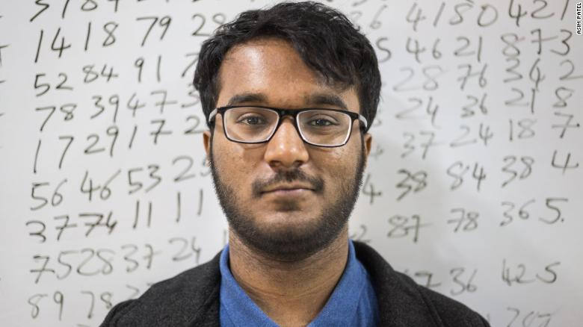
Neelakantha Bhanu Prakash is known in India as the "world's fastest human calculator."
(CNN)What's 869,463,853 times 73?
While the average person would still be reaching for their calculator, 20-year-old Neelakantha Bhanu Prakash already has the answer.
It's 63,470,861,269 and it takes just 26 seconds for Bhanu, known in India as the "world's fastest human calculator," to work it out in his head.
According to the Limca Book of Records -- India's equivalent to Guinness World Records -- Bhanu's mind processes numbers at an average speed of 12 per second, around 10 times faster than a regular brain.
Bhanu says he's able to make such complex calculations at breakneck speed through "structured practice."
"Let's say I am doing a multiplication of 8,763 multiplied by eight," he says. "I'll probably multiply: 8,000 by eight which is 64,000, 700 by eight which is 5,600, 60 by eight which is 480, three by eight is 24. And I add all of these. But this requires the human brain to remember all this.
"The methods which I use are very similar to general methods but certain things -- basically (it's) brain optimization. I optimize my methods and make them better than before.
"At the end of the day whatever I call my methods, sometimes it just happens. There's a certain process, obviously, but since you have trained your brain, it just happens."
On August 15, Bhanu, from Hyderabad in India's southern Telangana state, became the first Asian to win gold at the Mental Calculation World Championship at the Mind Sports Olympiad (MSO) in London. He's also the first non-European winner in the event's 23-year history.
In his competition debut, Bhanu beat 29 opponents from 13 countries to take the gold -- his speed so extraordinary that judges made him jump through extra hoops and solve more calculations to confirm his accuracy.
Just don't call him a prodigy.
"Definitely not, because I find the word 'prodigy' a little troubling as it just doesn't capture the efforts and experience, it's just a state that's obtained out of nowhere," Bhanu says, stressing that his extraordinary mathematical ability didn't come easily.
In fact, it could have all been very different.
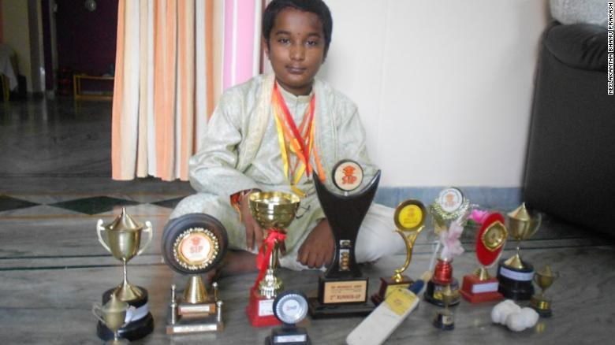
Bhanu, aged 10, poses with his haul of math tournament trophies in 2010.

Life-threatening injury
In 2005, aged 5, Bhanu fell from his cousin's scooter when it was hit by a truck, banging his head on the road.
Bhanu fractured his skull. He needed 85 stitches and multiple operations, before doctors put him into a medically induced coma.
When he woke up almost seven days later, the doctors told his parents that Bhanu could be cognitively impaired for the rest of his life due to his head injuries.
He spent the next year bedridden.
"That accident changed the way I used to define fun and it is the reason why am here today," he says.
During his recovery, Bhanu learned how to play chess and solved puzzles to keep his brain engaged -- eventually progressing to math problems.
"I remember the pain vividly ... this is the most traumatic experience I have had in my life," he recalls. "I couldn't even go to school for a year. All I had to rely on to get better were numbers and puzzles."
The head injury left him with an "ugly looking scar." To protect his feelings, Bhanu's parents removed all mirrors from around the house for a year. But he was determined to not let the scar define him. "It drove me forward and I knew there's something that I am good at and I will prove myself there," he says.
In 2007, aged 7, Bhanu finished third in the sub-junior category at a state level speed arithmetic competition in Andhra Pradesh state. His performance brought his father to tears, Bhanu says. "It wasn't the medal, it was what led me there that moved my father," he says.
Bhanu has since secured many wins, including the open category in India's 2011 National Speed Arithmetic Competition. And from the age of 13, he's represented India in international competition and broken four world records for fastest human calculation, power multiplication, super subtraction, and mental math: powers of 2 and 3.
He's also broken 50 Limca records, earning comparisons with legendary Indian mathematician Shakuntala Devi.
"When I am attempting a world record it's almost like the world around me slows down," Bhanu explains, drawing a comparison with a DC Comics superhero.
"It's kind of like 'The Flash' -- where when he runs everything else around is blurred. It definitely feels nice but also feels extremely liberating to actually do these complex calculations at this pace.
"So the neurons firing in the brain lead us to make believe that we are capable of doing things which we don't imagine. So I would say you almost feel like a superhero. Almost."
Bhanu's head injury left him with a scar, but he was determined not to let it define him.

Making math cool
Bhanu says he is passionate about his goal to "eradicate math phobia," the fearful feelings many of us have toward mathematics that can lead us to avoid situations in which we have to perform calculations and negatively impact our life choices.
According to a 2002 study published in the journal Current Directions in Psychological Science: "Highly math-anxious individuals are characterized by a strong tendency to avoid math, which ultimately undercuts their math competence and forecloses important career paths."
In 2018, Bhanu founded Exploring Infinities, an educational organization that aims to make math cool, challenging, interesting and immersive, by tracking cognitive ability development through arithmetic games.
"My experience began the day I went to a rural government school (in India) and realized kids there did not know that multiplication is repetitive addition," Bhanu explains. "That's what struck a chord and that's when I began my firm."
The organization, which has half a million subscribers, works at the grassroots level in India and, pre-coronavirus, organized math bootcamps in Bangladesh and Indonesia. Its digital learning program also has students from the United Kingdom and United States.
"Bhanu dominated the Mental Calculations World Championship and finished 65 points ahead of everyone else," says Mind Sports Olympiad CEO Etan Ilfeld.
"He continues to inspire through his outreach work including TEDx talks and his startup Exploring Infinities, which emphasize that anyone can improve their math skills and make the world a better place".
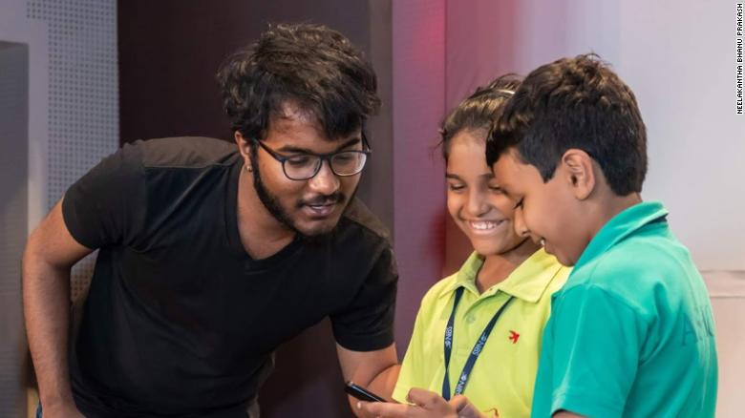
Bhanu does the math with two aspiring aspiring young mathematicians.
Bhanu's recent success caught the attention of India's President Ram Nath Kovind and Vice President M. Venkaiah Naidu, who congratulated him on his MSO win.
After years of struggling for state funding to take part in international competitions, he hopes his victory will usher in a new era of support for India's aspiring mathematicians to compete at the world level.
"For any country to develop and thrive globally, numeracy is as important a skill as literacy," he says.
"Three out of every four students who study in the government schools of India have trouble understanding basic mathematics."
Bhanu says his debut MSO victory may also be his last in the tournament, as he focuses instead on his philanthropic work.
"I am not sure if I am going to be participating in competitions anymore," he says. "I don't think I should. I have established my point that I am quicker. I am in a position that people hear me, I better use it.
"I don't want to be the face of mathematics -- there are enough of those, and they are exceptional. I want to be the face against math phobia. Very simple."

