The First Chemist – A Breath of 3000-Year-Old Air

<https://fourdestinationsblog.wordpress.com/2017/07/16/the-first-chemist-a-breath-of-3000-year-old-air/>

[July 16, 2017](https://fourdestinationsblog.wordpress.com/2017/07/16/the-first-chemist-a-breath-of-3000-year-old-air/)[fourdestinationsblog](https://fourdestinationsblog.wordpress.com/author/fourdestinationsblog/)

Perfumes have been widely sought-after goods in many cultures for most of human history. Even Mesopotamia, the world’s earliest civilisation, had its talented perfumers working in their essential and highly technical aromata industry. However, one perfumer stood out in particular. Her name was Tapputi and she is considered to be the first chemist in history.

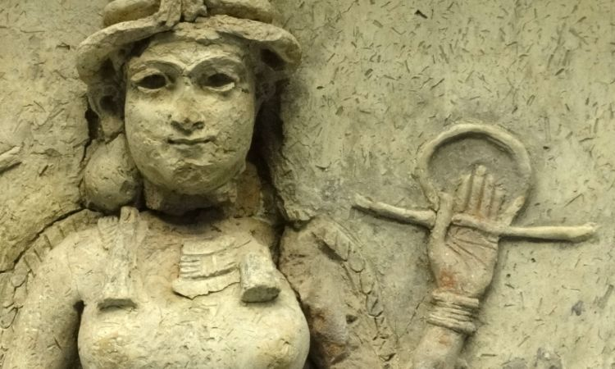Tapputi Belatekallium

Cuneiform (first written language) tablets from c. 1200 BCE have recorded her titles as well as her concoctions. She held the title, Belatekallium (female overseer), meaning she worked at the royal palace and was paid to make perfumes for the king. One tablet’s recipe is also the first known reference to a still. She experimented with distillation, cold enfleurage, tincture and many other scent extraction techniques. Her most notable technique was using solvents, which gave similar results to modern perfumes. Tapputi blended oils, essences, and resins, then cut them with a mix of distilled water and grain alcohol. Hence, her scents were lighter, brighter, further reaching, and longer lasting than any perfume oil the Babylonians. Her methods became the foundation for natural perfume making. Then, to preserve her floral scents across the Babylonian Empire, she prepared fragrant oils in a concrete of fat and wax.

Here is the preparation of flowers, oil and calamus for the king according to the recipe of Tapputi-Belatekallium, the perfumer:

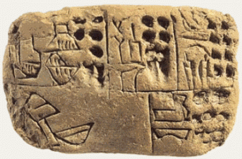Cuneiform Tablet

If you prepare flowers, oil and calamus as a salve, and you have tested the flowers; you set up… a distillatory. You put good potable water [into a hairu pot]. You heat tabilu and put it in. You put 1 qa haminu, 1 qa iaruttu, 1 qa of good, filtered myhrr into the hairu put. Your standard in this is the water taken and divided. You operate at the end of the day and in the evening. It remains overnight. It becomes steeped.

You filter this solution… with a filter cloth into a hirsu pot at dawn, on the rising of the sun, you clarify from this hirsu pot into another hirsu pot. You discard the residue. You use 3 qa of purified Cyperus in the solution with the aromatics. Discard the inferior material. You put 3 qa myrrh, 2 qa pressed and filtered calamus in the solution with these aromatics… 1 ½ pure gullu… two beakers… small beakers… you filter… kanaktu in a sieve. You decant the oil in the hairu pout… in the solution [you rub that which was with the solution overnight] [you examine] the comminuted material. You remove [its bad part]. You filter this solution which [you clarified into a distillatory] … 3 qa… [you throw]… balsam into this solution in [a hirsu pot]. [you kindle a fire]. When the solution is heated for admixture, [you pour in the oil]. You agitate with a stirrer. [When the oil, solution, and aromatics] continue to dissolve, [you raise] the fire… you cover the distillatory on top. [you cool] with [water]. When the sun rises,[you prepare] a [container for] the oil, solution and aromatics.

You allow the fire under the distillatory to die down. You remove the distilled and sublimed substances from [the trough of the distillatory].

When the sun [rises],[if] they continue to dissolve in one another and [the fire rises], you cover the [top] of the distillatory. You cool. You prepare a flask for the calamus oil. You put a filter cloth over the flask. You remove the dregs and residue left in the distillatory.

It is unfortunate that her works were lost for 1000 years, and even after being rediscovered, she still does not receive much recognition. Yet the fact remains that the first chemist in the world, was a woman named Tapputi.

-Saima

Who Was the First Chemist? A Woman Named Tapputi

*This entry was posted on*[*December 27, 2017*](https://sciencenotes.org/2017/12/27/)*by*[*Anne Helmenstine*](https://sciencenotes.org/author/azareal/)*(updated on*[*January 1, 2018*](https://sciencenotes.org/2017/12/27/)*)*

<https://sciencenotes.org/who-was-the-first-chemist/>

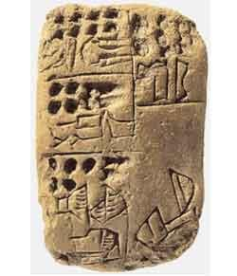

*Tapputi-Belatekallim, a female chemist and perfume maker, is mentioned on a Mesopotamian tablet from around 1200 B.C.E.*

The first known chemist was a woman. A Mesopotamian cuneiform tablet from the second millennium B.C. describes Tapputi, a perfumer and palace overseer who distilled the essences of flowers and other aromatic materials, filtered them, added water and returned them to the still several times until she got just what she wanted. This is also the first known reference to the process of distillation and the first recorded still. Tapputi also worked with tinctures, scent extraction, and cold enfleurage. She wrote the first treatise on making perfume, but this chemistry text is now lost.

Tapputi and Ninu

Tapputi is also known as Tapputi-Belatekallim. “Belatekallim” means “female palace overseer,” indicating Tapputi held a position of importance at the Mesopotamian court. The cuneiform tablet says she worked with another woman name (—)ninu (the first part of the name cannot be read). One of Tapputi and Ninu’s recipes survived to the present day. The recipe is for a perfumed salve made using calamus, myrrh, oil, and flowers, intended for use by the king.

**References**

* Alic, M. *Hypatia’s heritage, a history of women in science from antiquity through the nineteenth century*. Boston, MA: Beacon Press, 1987. 22.
* Rayner-Canham, Marelene, and Geoffrey Rayner-Canham. *Women in Chemistry: Their Changing Roles from Alchemical Times to the Mid-Twentieth Century*. 1st edition. Chemical Heritage Foundation, 2005.

**Don’t forget Tapputi-Belatekallim**

The neglected contributions of female scientists through history.

<https://cosmosmagazine.com/chemistry/forgotten-women-in-science-tapputi-belatekallim>

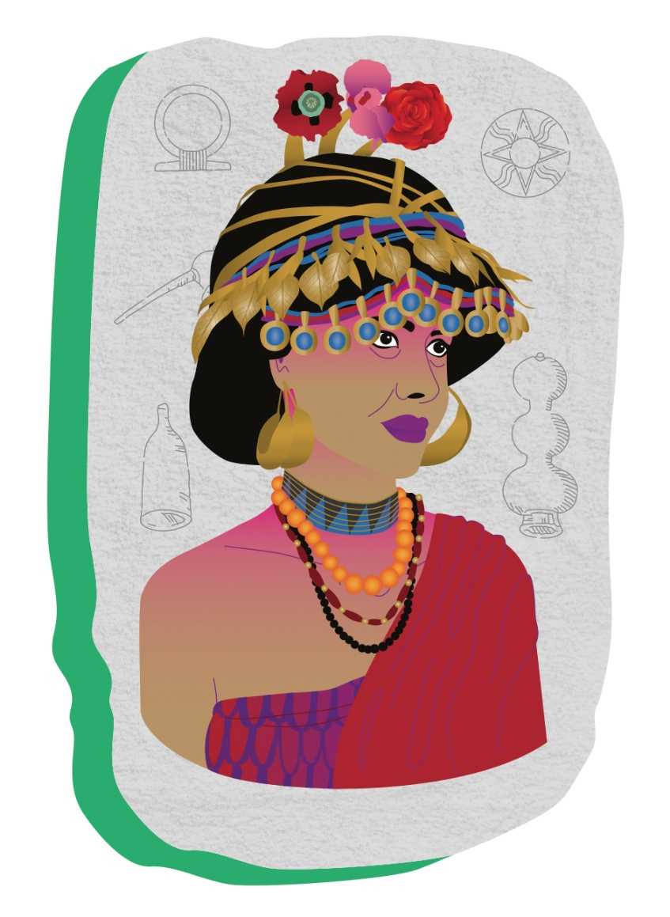

Tapputi-Belatekallin. Credit: Hélène Baum

The history of women in science doesn’t just go back to tales of female scientists and philosophers such as Hypatia of Alexandria; it also extends some 6,000 years back to ancient empires in Mesopotamia, the cradle of civilisation.

Many of these women’s names have since been lost in time and all that remains of them are depictions of their likenesses in stone carvings. But one of the first women whose name we do know belongs to that of a Babylonian chemist: Tapputi-Belatekallim (c.1200 BCE).

Archaeologists found a record of her work in clay cuneiform texts dating back to 1200 BCE. In ancient Babylon, perfumes were not just cosmetic scents for beauty purposes: they were fragranced substances that were required for medicinal purposes and religious rituals alike.

As a royal perfume-maker, Tapputi wasn’t just the head of her own household (which is what “Belatekallim” means); she is spoken of as being an authority in her field and the official overseer of perfumery in the royal palace.

As any modern-day perfumer will tell you, the creation of perfumes – even for cosmetic reasons alone – doesn’t just entail mixing up scents to see what smells nicest. It requires an intimate knowledge of chemistry and an understanding of technical processes such as extraction and sublimation. Tapputi wielded these skills well over a millennia ago.

We know little of Tapputi’s background or personal life, but history has left us with one of her recipes: a fragrant salve for the Babylonian king. In this fascinating relic, Tapputi takes the reader through the step-by-step routine necessary to produce a royal ointment containing water, flowers, oil and calamus, which may either refer to lemongrass or a reedlike plant that is still used in perfumes today. {%recommended 6859%}

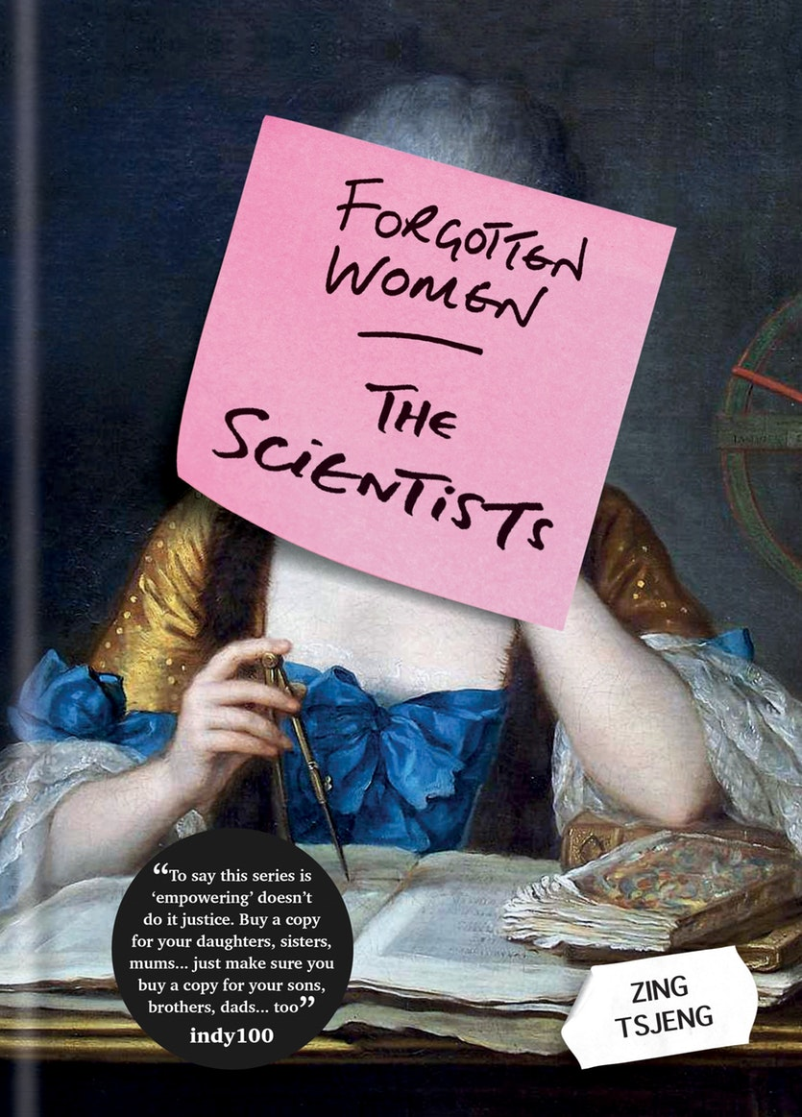She describes the process of refining the ingredients in her ‘still’: a chemical apparatus for distilling and filtering liquids. Advanced versions of such equipment remain in use in labs today, but Tapputi’s reference to a still is the oldest in human history. That makes her one of the earliest chemical engineers that we know of.

Tapputi is not the only woman mentioned in the cuneiform tablets about perfumery. Another female chemist is noted in these records, though the first half of her name has been lost. We only know her as “[–]ninu”, though she is described as the author of a text on perfume manufacturing.

It’s not surprising that women were so intimately involved with chemistry. The list of equipment used seems to be co-opted straight from a Babylonian kitchen or adapted and modified from everyday utensils and cookware. This appears to suggest that women were chemistry’s earliest adopters and innovators, and that there is a lot less separating the art of cuisine from the science of chemistry than many people may think.

*This is an extract from*[*Forgotten Women: The Scientists*](https://www.hachette.com.au/zing-tsjeng/forgotten-women-the-scientists)*by Zing Tsjeng. Published by Hachette Australia, RRP*



# **Tapputi – The World’s First Chemist**

<https://makethemmainstream.com/2018/08/22/tapputi-the-worlds-first-chemist/>

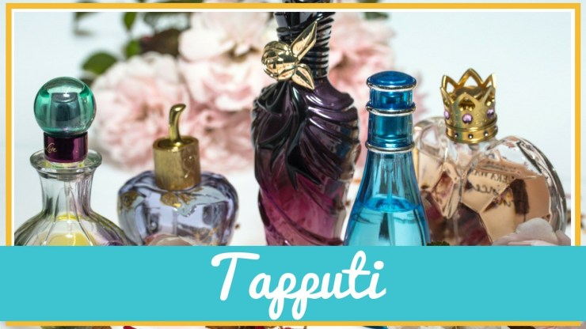

The world’s first chemist was a Babylonian woman named Tapputi who lived around 1200 BCE.

It is difficult to tell the story of Tapputi in the same way that I tell the story of the other women on Make them Mainstream. Since she was born so long ago, her life was not as well documented. We cannot simply go through her life from childhood to academic life to professional life.

However, that doesn’t make her story or her accomplishments any less fascinating.

So… this is the story of **Tapputi**, *the world’s first chemist*!

Tapputi was a Babylonian Noblewoman. ***She was the royal perfumer, head of the royal perfumery, and head of the royal household.***“We know little of Tapputi’s background or personal life, but history has left us with one of her recipes: a fragrant salve for the Babylonian king.” [1]

*Her full title was Tapputi-Belatekallim. Belatekallim means the head of the household.*

You see, all the way back in 1200 BCE perfume was not just used for beauty purposes. Perfume was used for medicinal and religious purposes as well. Perfume was a staple in Babylon because perfume was a standard ritual offering.

The typical perfume was a thick oil of Frankincense. Tapputi’s perfumes were light, extremely aromatic, and lasted for hours.

She was able to combine multiple scents into one perfume.

Tapputi used solvents to distill the perfume making them light, and long-lasting. “As any modern-day perfumer will tell you, the creation of perfumes – even for cosmetic reasons alone – doesn’t just entail mixing up scents to see what smells nicest. It requires an intimate knowledge of chemistry and an understanding of technical processes such as extraction and sublimation.” [1]

Due to her abilities and the***importance of her work***, scribes would write down her recipes into clay tablets for future use. She was known as an authority figure in chemistry and perfumery.

*Scribe – a person who copies out documents, especially one employed to do this before printing was invented.*

One tablet “tells us that Tapputi used the first recorded still in history and wrote the first treatise on perfume making, which is now lost. Her revolutionary techniques are recorded in secondary sources, including distillation, cold enfleurage, tincture, and scent extraction. She also developed a technique for using solvents – like distilled water and grain alcohol.” [2]

Tapputi did not do her work alone; she had an assistant, another woman whose full name has been lost to history.

Many of the tools she used were also used in the kitchen. ***It appears that the art of chemistry and food science were just as related back then.***

Though her story is brief, her legacy is powerful. Even back in 1200 BCE, Tapputi was seen as an authority figure in her profession.

To learn more about influential females in STEM then please visit the [**Women in STEM Blog**](https://makethemmainstream.com/category/women-in-stem/). Here I talk about all kinds of [**females in STEM**](https://makethemmainstream.com/category/women-in-stem/). If there is a woman in a specific type of field in Science, Technology, Engineering, or Mathematics that you want to hear about, leave a comment below.

Happy Learning,

Danielle Connolly Signature Make them Mainstream Women in STEM Female STEM Education

**Works Cited**

[1] <https://cosmosmagazine.com/chemistry/forgotten-women-in-science-tapputi-belatekallim>

[2] <https://www.girlmuseum.org/tapputi-belatekallim/>

[3] <https://deathscent.com/2016/03/08/the-lost-history-of-women-in-chemistrythe-first-perfumer/>