IB 4 SL WS Comparing different simulations to calculate bond angles
Working with single bonds and carbon. Go to this site:
http://biomodel.uah.es/en/DIY/JSME/draw.en.htm
For IB Standard and Higher Level you need to be familiar with the VSEPR theory which can be summarised for 4 electron centres as this:

Top Tips to Easier, More Smashing!!! Work
- As soon as you read this, save this document with your English name at the beginning of the filename.
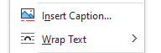
- Make sure you read the whole of this document before you start, it will make your work much better and save you a lot of time!
- If you change a pictures Wrap Text properties it is much easier to move the picture around (right mouse click, then this option:
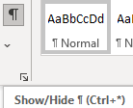
- If you press these buttons in order “Alt” then “H” then “8” you will be able to see what MS Word is trying to do with your formatting (is there another quicker way to do this?):
- If you press “Ctrl” + “Enter” you can introduce page breaks and have different sections of your work always appear on new pages.
- If you press “Alt” then “S” then “T” then “Enter” you can create a table of contents for this document. Put one in at the start of this document
- To work with the web page and the Word Document side by side in one window press “⊞ Win” + “” (arrow key), for the other program click inside it then “⊞ Win” + “”.

Introducing the basics to the program
- To draw propane, start by clicking on the “C” button and anywhere in the 2D workspace:
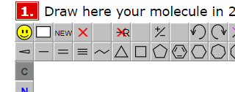
- Then click on the line button:
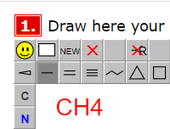
- Now extend the structure so that it has 2 lines, and three points. Clicking on the arrow key will convert it into a 3D model. You can chose different 3D models and chose the one that looks best.
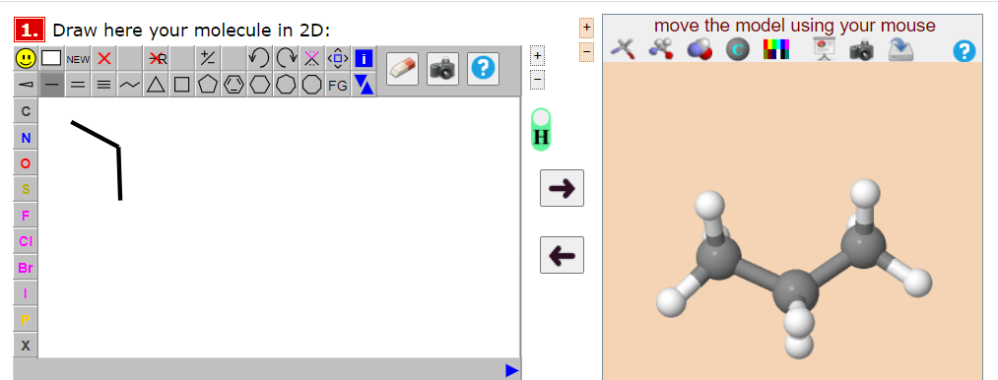
- Try rotating the molecule and experiment with the different types of 3D representations of the molecules:
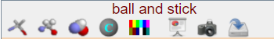 You should see different models like this:
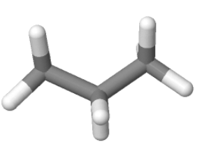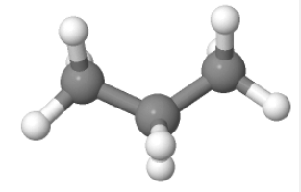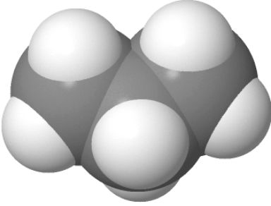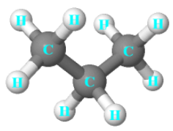

- To take a screen shot press “⊞ Win” + “Shift” +”S” at the same time.
- If you double click on a central atom you can also get the program to work out bond angles and distances in the molecule.
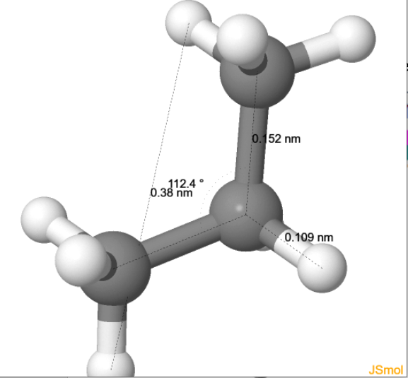

Part 1: Learning to draw in 2D
To change from normal typing to _{subscript}, used for the 2 in H₂O, on a PC type “Ctrl” + “=”, helpful for filling out this table.
Fill in the following table with
- The formula for each molecule (use the program or the internet to help if you are unsure)
- Screenshots showing that you have made the following molecules. Try to make them roughly the same size.
# | Small simple molecular substance | Formula | Screenshot of the 2D molecule
1 | Iodine |  | 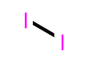
2 | Chlorine
3 | Oxygen
4 | Nitrogen
5 | Water
6 | Methane
7 | Ammonia
8 | Beryllium difluoride
9 | Boron trifluoride
10 | Ethane
11 | Ethanol
12 | Ethene
13 | Ethanoic Acid
14 | Ethyne
15 | But-1-ene
16 |  | C₆H₆
17 | Octane
18 |  | C Cl₂F₂
19 | Your name
20 | Interesting molecule

Write a version of your name using carbon atoms, put a screenshot in the table above.
Find an interesting molecule, like caffeine or penicillin, write it’s name in the area above in gray and try to draw it out using the program and put it into the table above.

Part 2: Translating 2D structures into different kinds of 3D structures
Before you delete the molecules you have made above, take two screenshots of them represented in 3D. If you have already deleted them, just more on and start from the beginning. But in future, make sure you read all of the instructions before you start!
To make it easier to work with tables it is best to use the ruler at the top of the page in MS Word:
To get it “Alt” then “H” then “R”. To use it for a table, click anywhere inside the table, then holding left click on the hashtag dividers (where the blue arrow below is pointing) in the ruler, resize your table:
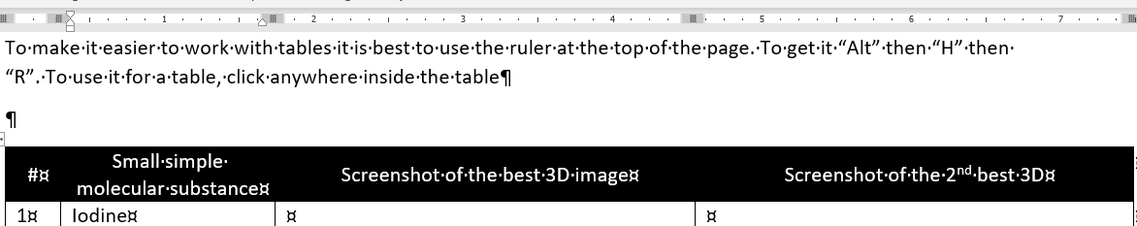

If your table gets too big and goes off screen use the “Web Layout” (at the bottom right corner) to see the whole page:
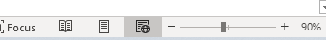

# | Small simple molecular substance | Screenshot of the best 3D image | Screenshot of the 2nd best 3D
1 | Iodine
2 | Chlorine
3 | Oxygen
4 | Nitrogen
5 | Water
6 | Methane
7 | Ammonia
8 | Beryllium difluoride
9 | Boron trifluoride
10 | Ethane
11 | Ethanol
12 | Ethene
13 | Ethanoic Acid
14 | Ethyne
15 | But-1-ene
16
17 | Octane
18
19 | Your name
20 | Interesting molecule

Part 3: Working out the bond angles around each of the central atoms described below
To work out the bond angles you are going to need to “Optimise” using the button (Step 4) shown below:
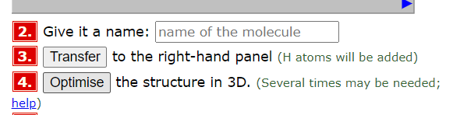
If you have not started the tables above, Congratulations!!! You can celebrate by having better images in your table, can take screenshots after you have optimised the structure for each molecule and put them into the table above. If you have already completed the tables above, Congratulations!!! You have just learnt that you should follow written instructions more carefully, DON’T go back and change your work, just move on, but in future read!!!
To quickly switch into ^{superscript} type and back into normal type on a PC type “Shift” + “Ctrl” + “=” at the same time. This will allow you to easily type in an easy version of the angle sign, which is just a superscript lower case “o”, as in ºC.
Small simple molecular substance | Central atom underlined | Predicted VSEPR bond angle | Bond angles that your model has calculated | Published value of bond angle | Screenshot of the optimised 3D image with bond angles shown
Water | O
Methane | C
Ammonia | N
Beryllium difluoride | Be
Boron trifluoride | B
Ethane | C
Ethanol | CH₃CH₂OH
Ethene | C
Ethanoic acid | CH₃COOH
Ethanoic acid | CH₃COOH
Ethyne | C
But-1-ene | CH=CHCH₃
Benzene | C
Octane | CH₃ (CH₂)₆CH₃
C Cl₂F₂ | C
Your name | Choose one

Part 4: Drawing Giant Macromolecular Molecules
Try to draw a 16-carbon version of diamond, and put a screenshot below:

Now optimise it, and put the image below:

Try to draw a sheet of graphite (called graphene). Remember, graphite has flat! Put a screenshot in below:

Now optimise it, and put the image below:

By measuring distances within your molecule work out how many atoms are within 1mm of stance. Then work out how many atoms would be a in a 1mm³ cube.

Extension: Try to draw a few sections of Silicon (IV) Oxide. The element silicon is not represented so you will need to use carbon instead. Put a screenshot in below:

Now optimise it, and put the image below:

Part 5: IB SL Extension
Investigate each of the molecules above and find out the actual bond angle and write it in the table above in the gray area.

