ALvl Chem 5 PPT EQ 2021.m.TZ2.P5.Q1 10marks Thermometric Temperature Changes WS
Q# 72/ Chem 5 ALvl Chemistry/2021/m/TZ 2/ Paper 5/Q# 1 /www.SmashingScience.org :o)
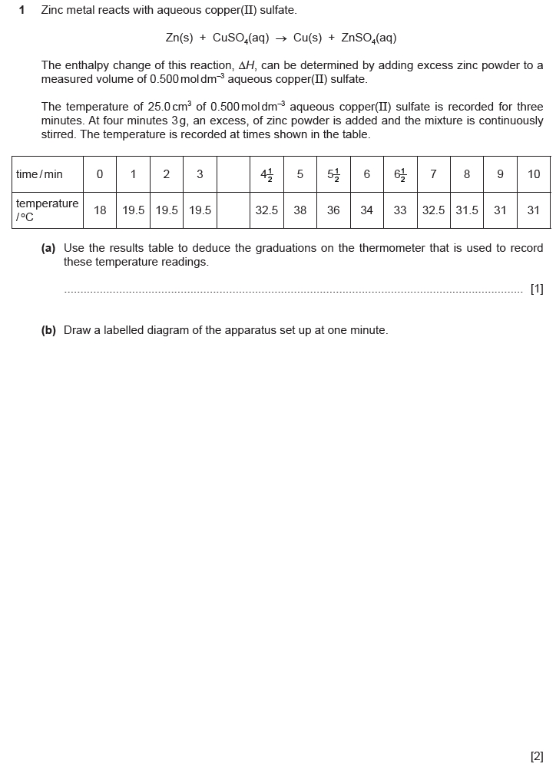
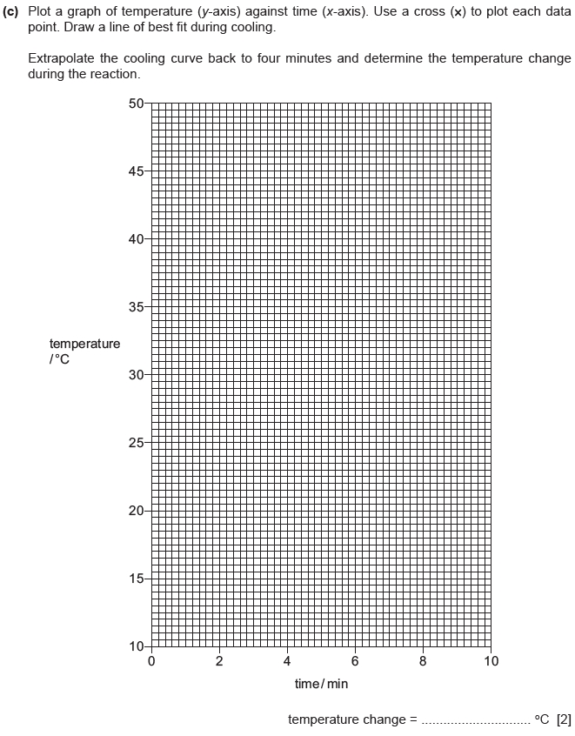
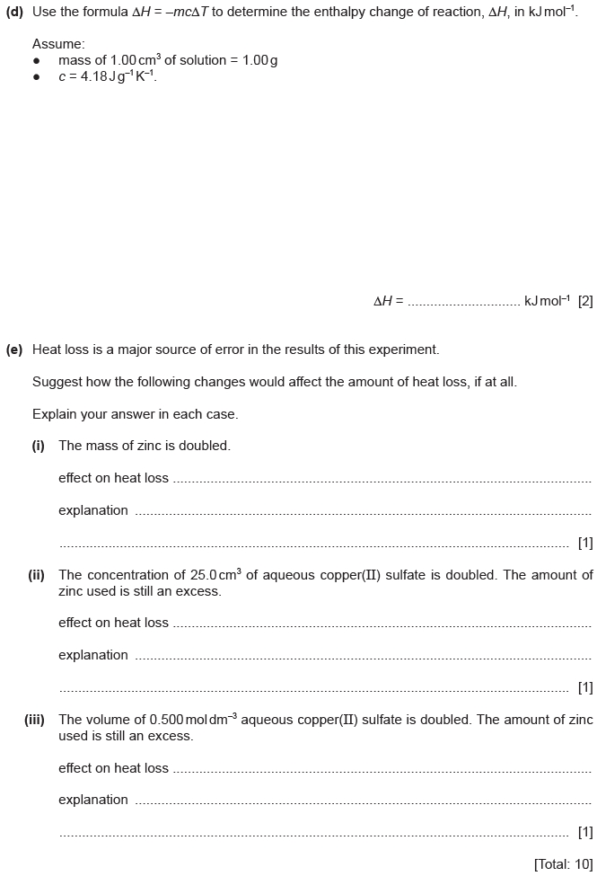

ALvl Chem 5 PPT EQ 2021.m.TZ2.P5.Q1 10marks Thermometric Temperature Changes WS MARK SCHEME
Q# 72/ Chem 5 Thermometric (temperature changes) ALvl Chemistry/2021/m/TZ 2/ Paper 5/Q# 1 /www.SmashingScience.org :o)
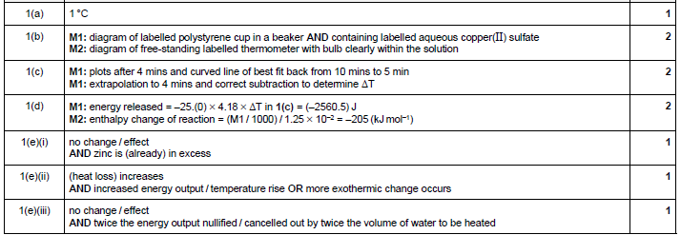

ALvl Chem 5 PPT EQ 2021.m.TZ2.P5.Q1 10marks Thermometric Temperature Changes WS MARK SCHEME
Q# 72/ Chem 5 Thermometric (temperature changes) ALvl Chemistry/2021/m/TZ 2/ Paper 5/Q# 1 /www.SmashingScience.org :o)

ALvl Chem 5 PPT EQ 2021.m.TZ2.P5.Q1 10marks Thermometric Temperature Changes WS MARK SCHEME
Q# 72/ Chem 5 Thermometric (temperature changes) ALvl Chemistry/2021/m/TZ 2/ Paper 5/Q# 1 /www.SmashingScience.org :o)

ALvl Chem 5 PPT EQ 2021.m.TZ2.P5.Q1 10marks Thermometric Temperature Changes WS MARK SCHEME
Q# 72/ Chem 5 Thermometric (temperature changes) ALvl Chemistry/2021/m/TZ 2/ Paper 5/Q# 1 /www.SmashingScience.org :o)

